Build Deployment Procedure - RH1

Schindler CRD Applications

Exported on 2025-08-19 05:07:13

Table of Contents

1 Introduction 4

2 Purpose & Scope 5

3 Pre-Deployment Steps 6

4 Compile Custom Resource Bundle 8

5 Increase Column length to 4000 10

6 BIF Package Deployment 11

7 Common Package Deployment 42

8 Update Environment Specific Properties 47

9 Lotus Deployment 49

10 Post Upgrade Steps 55

10.1 Create JMS Service 55

10.2 Update Translation Preferences 56

10.3 Update SchindlerCMSArbortextPublishRules 58

10.4 Update SchindlerCMSArbortextPublishRules - SC7 Product 59

10.5 Update SchindlerCMSTranslationPublishRules 61

10.6 Create AdHocAccessReport Task delegate 64

10.7 Update Sync on CA Complete robot to use Object Event 66

* Introduction
* Purpose & Scope
* Pre-Deployment Steps
* Compile Custom Resource Bundle
* Increase Column length to 4000
* BIF Package Deployment
* Common Package Deployment
* Update Environment Specific Properties
* Lotus Deployment
* Post Upgrade Steps
  + Create JMS Service
  + Update Translation Preferences
  + Update SchindlerCMSArbortextPublishRules
  + Update SchindlerCMSArbortextPublishRules - SC7 Product
  + Update SchindlerCMSTranslationPublishRules
  + Create AdHocAccessReport Task delegate
  + Update Sync on CA Complete robot to use Object Event

# Introduction

Schindler uses Windchill 12.0.2.11 as their PLM system. Schindler have requested Plural Technology to upgrade their existing Windchill version to Windchill 13.0.2.5  
Plural technologies Windchill Solution Architect had series of discussions and system visits to understand current architecture, usage and existing issues.

# Purpose & Scope

This document captures code porting and deployment of code from source Windchill 12.0.2.11 system to target Windchill 13.0.2.5 system using BIF deployment along with all the post deployment steps.

# Pre-Deployment Steps

* Set Below Environment variables on target system

*WT_HOME and ANT_HOME*

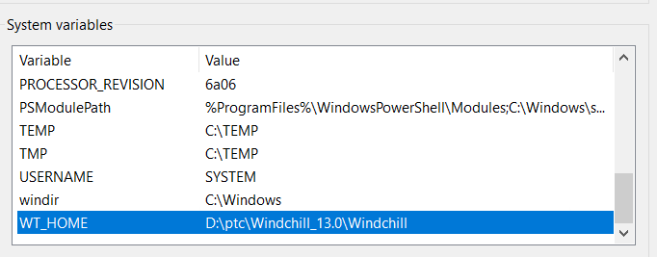

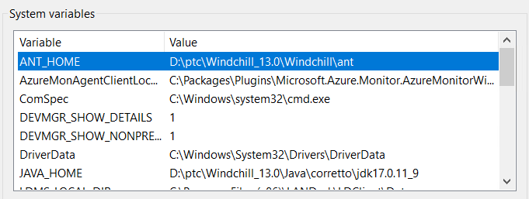

* Create Directory *D:/SVN_branches* on target system
* Copy and extract edm-windchill-master zip in newly created directory, it should have folder structure as shown in below screen shot.

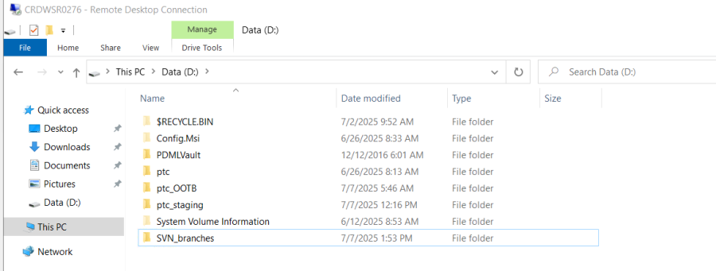

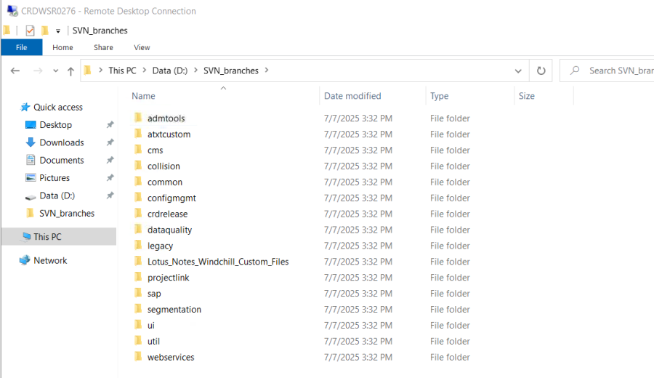

# Compile Custom Resource Bundle

* Copy wtCustom folder to <WC_HOME> directory

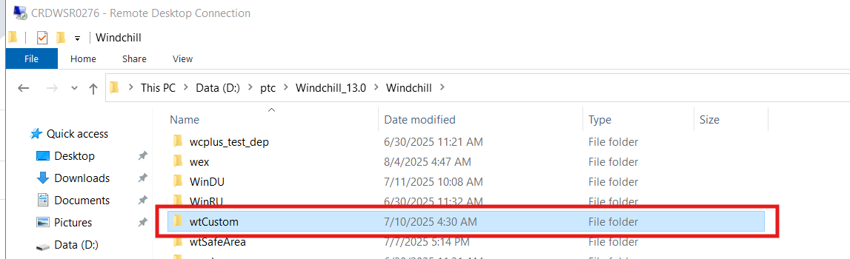

* Run below commands from windchill shell:

ResourceBuild ext.schindler.cms.tml.*.*

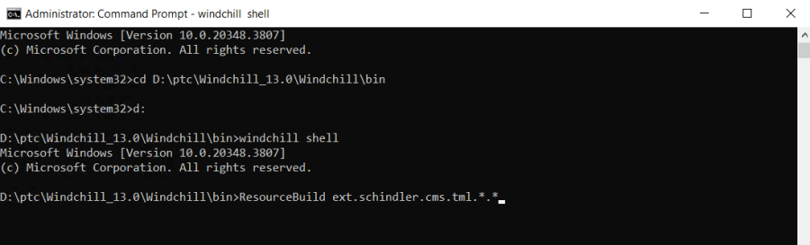

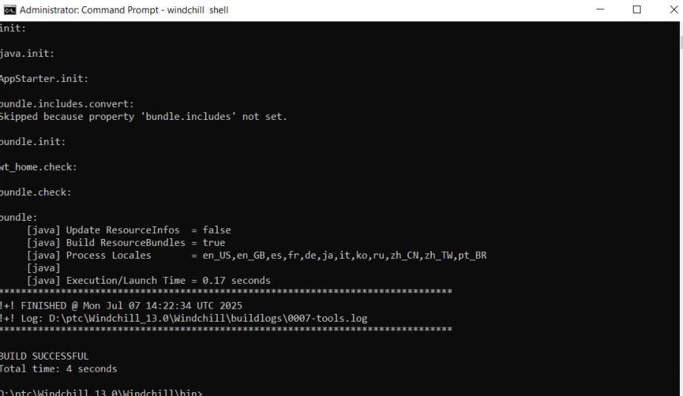

ResourceBuild ext.schindler.projectlink.saperion/*.*

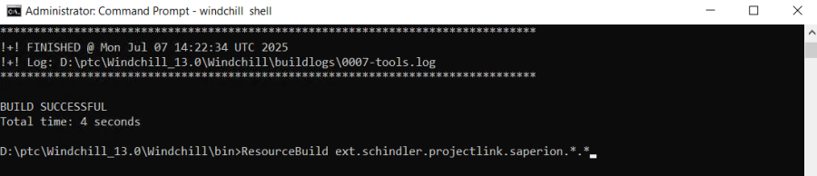

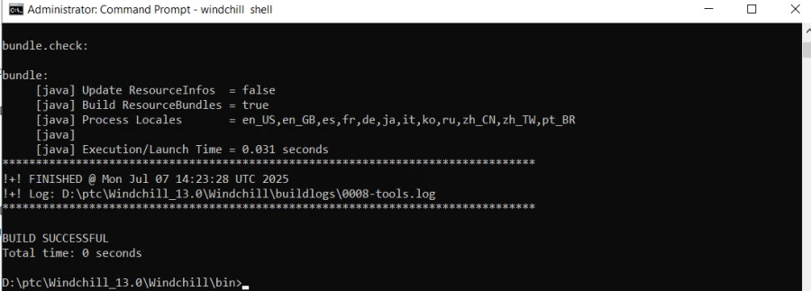

# Increase Column length to 4000

* Set below property before running upgrademanager -cs

xconfmanager -s "wt.db.maxBytesPerChar=1" -t codebase/wt.properties -p

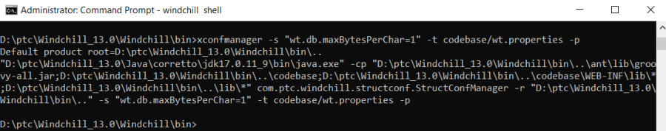

* Execute below command in Windchill Shell to generate class info objects

ant -f bin\tools.xml custom_column -Dgen.input=wt.iba.value

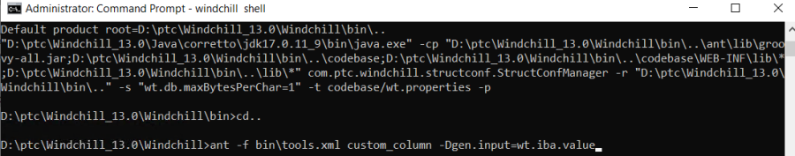

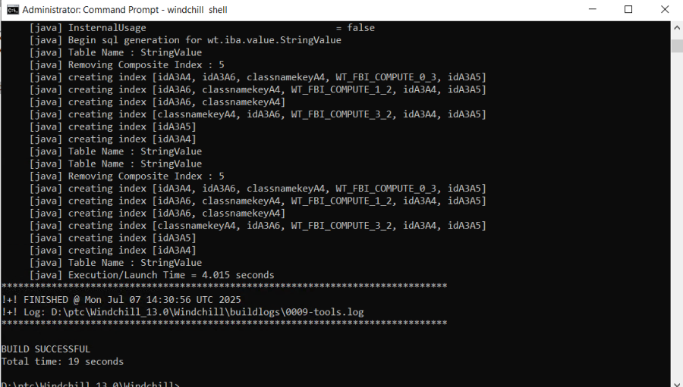

# BIF Package Deployment

* Open Command shell and navigate to location "D:\SVN_branches\util" and run below command

***java -jar srclib\BIFSDK-2.1.1.02.jar dist***

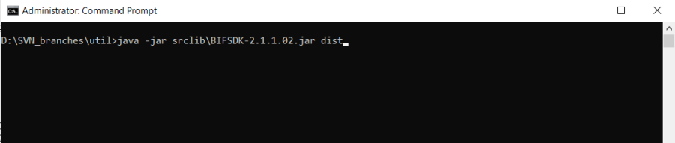

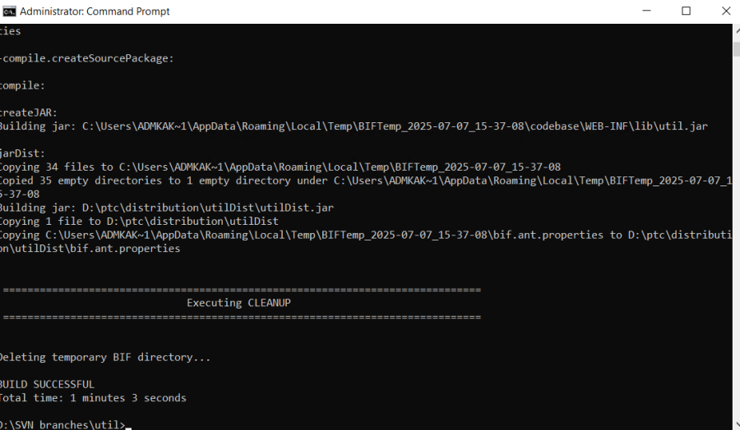

***java -jar D:\ptc\distributionutilDistutilDist.jar install***

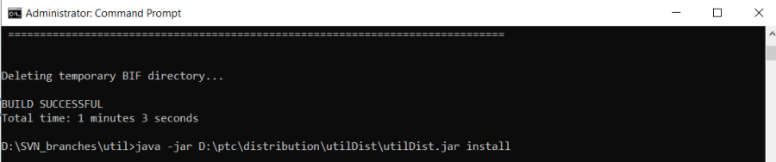

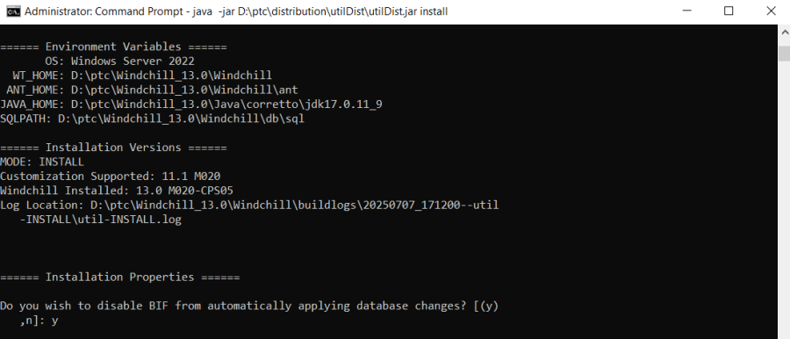

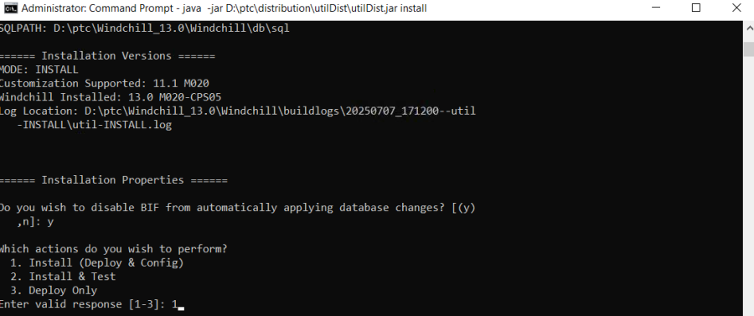

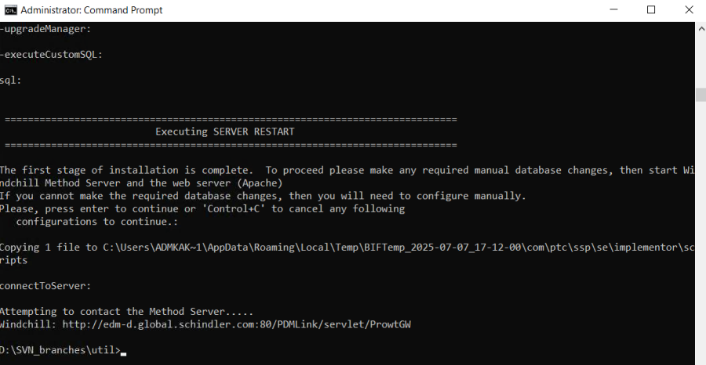

* Open Command shell and navigate to location "D:\SVN_branches\ui" and run below command

***java -jar srclib\BIFSDK-2.1.1.02.jar dist***

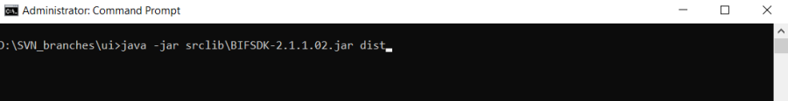

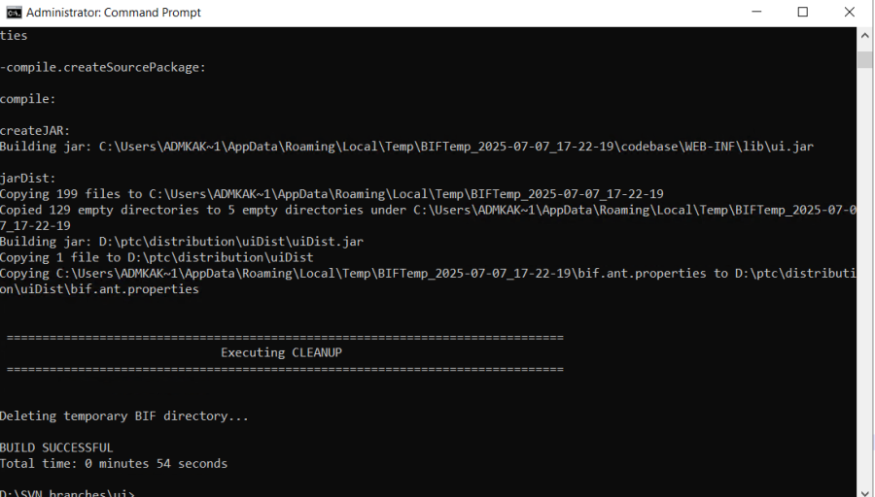

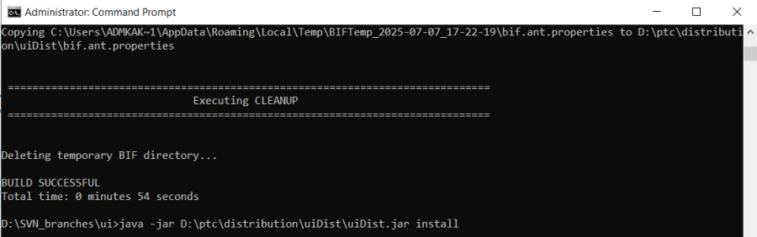

***java -jar D:\ptc\distributionuiDistuiDist.jar install***

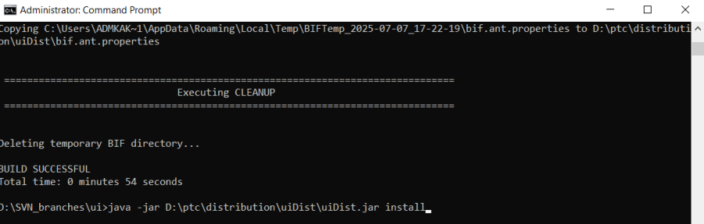

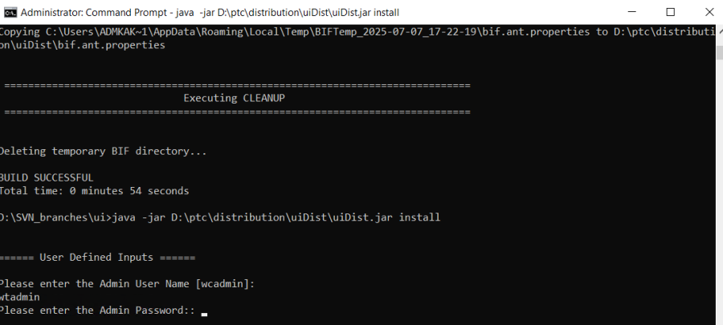

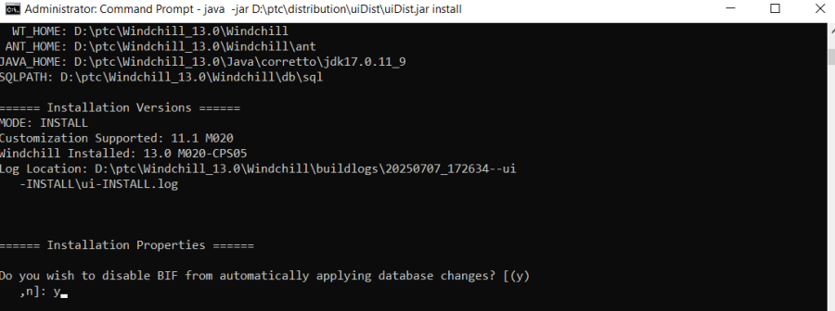

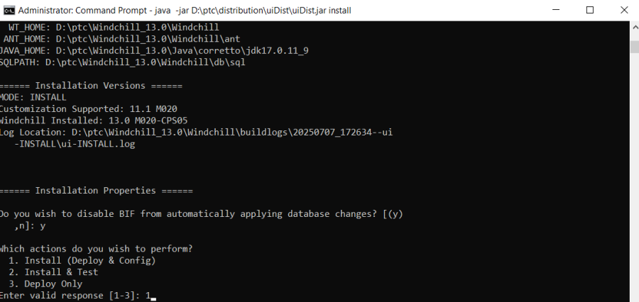

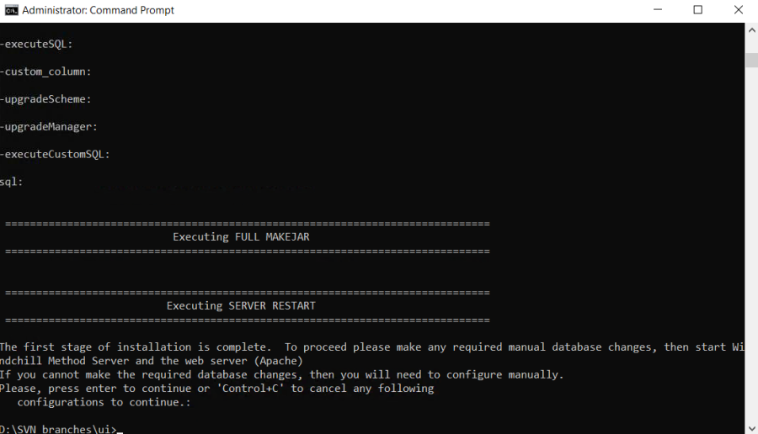

* Open Command shell and navigate to location "D:\SVN_branches\ projectlink" and run below command

***java -jar srclib\BIFSDK-2.1.1.02.jar dist***

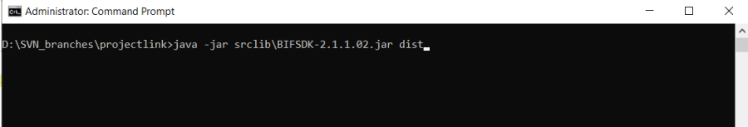

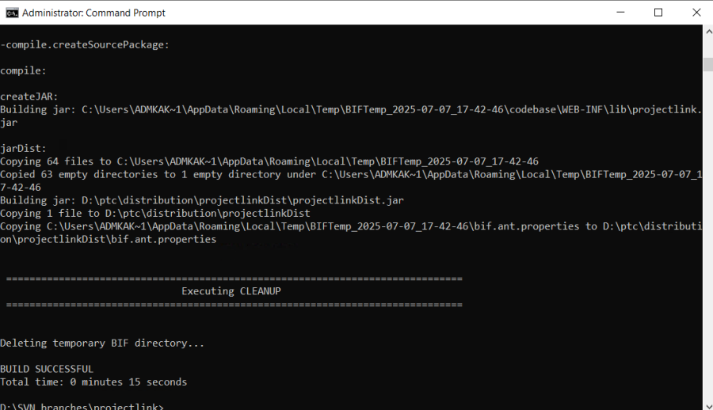

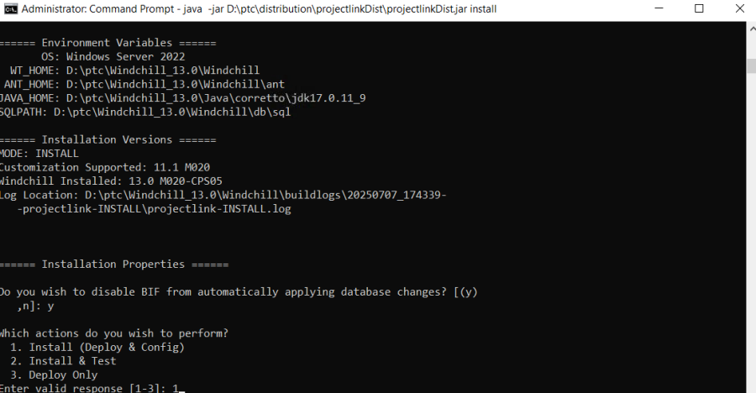

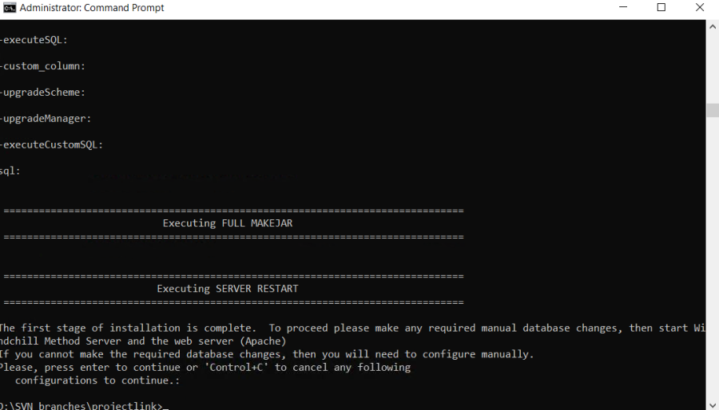

***java -jar D:\ptc\distributionprojectlinkDistprojectlinkDist.jar install***

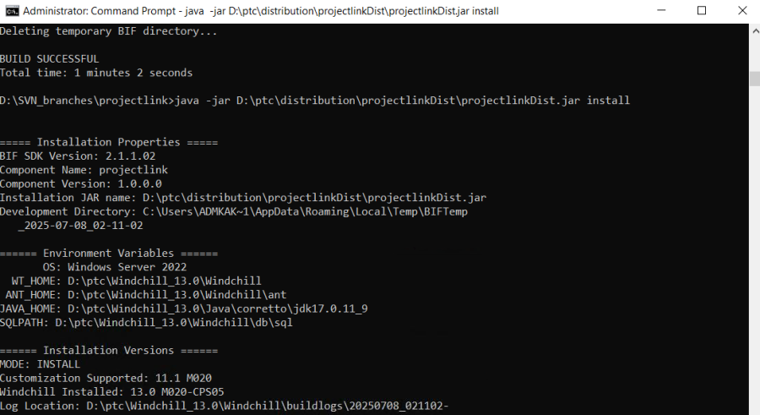

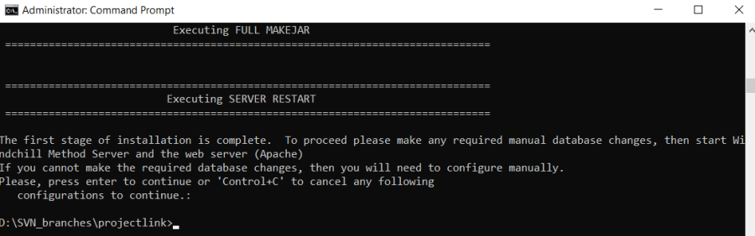

* Open Command shell and navigate to location "D:\SVN_branches\dataquality" and run below command

***java -jar srclib\BIFSDK-2.1.1.02.jar dist***

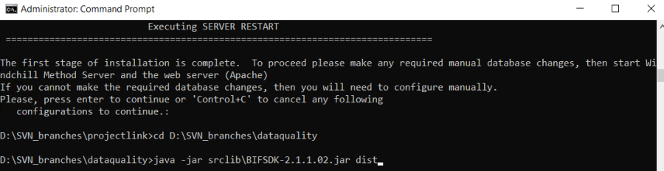

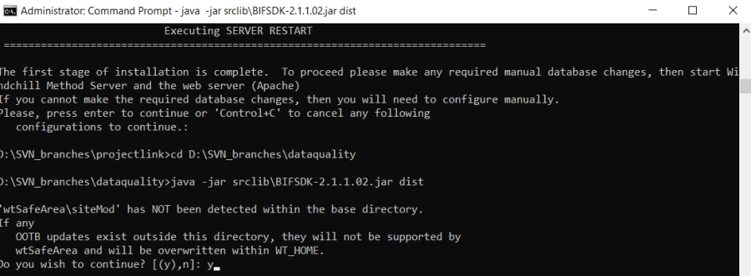

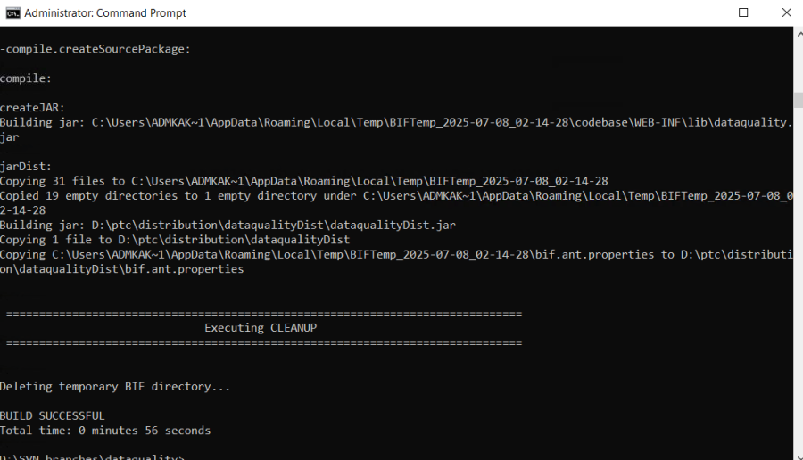

***java -jar D:\ptc\distributiondatqualityDistdataqualityDist.jar install***

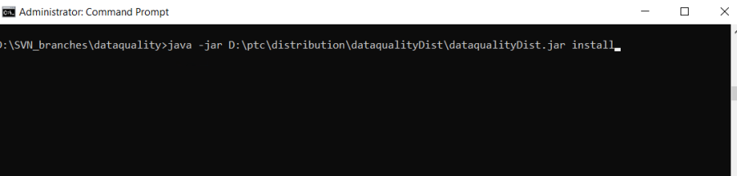

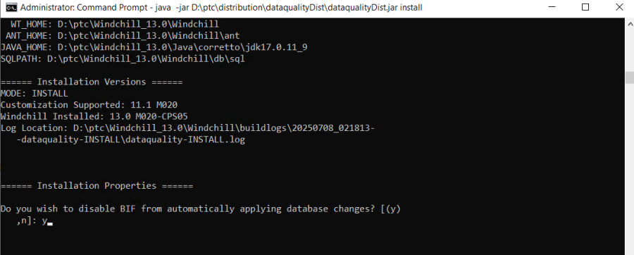

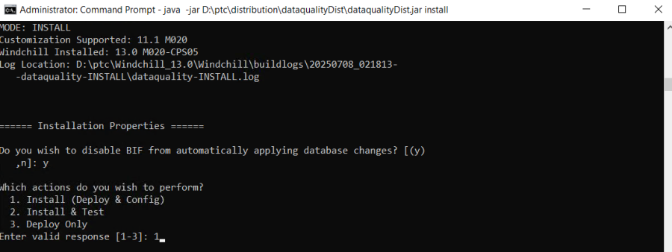

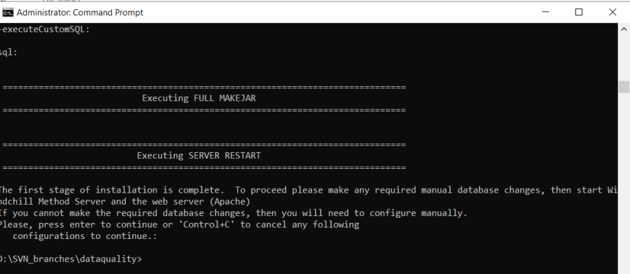

* Open Command shell and navigate to location "D:\SVN_branches\ webservices" and run below command  
  ***java -jar srclib\BIFSDK-2.1.1.02.jar dist***

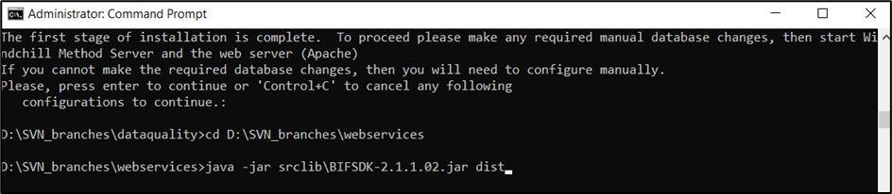

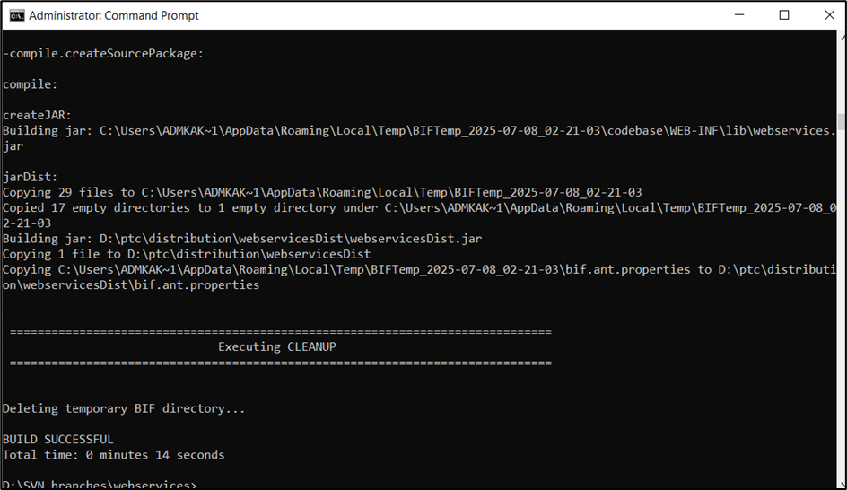

***java -jar D:\ptc\distribution\webservicesDist\webservicesDist.jar install***

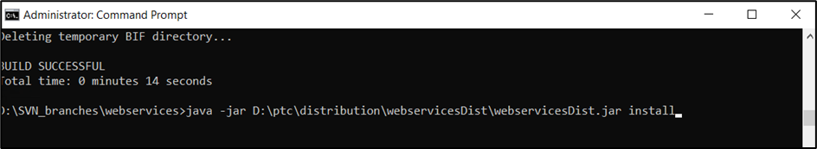

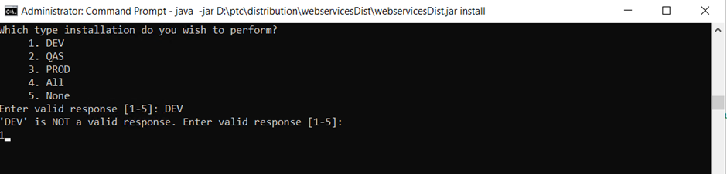

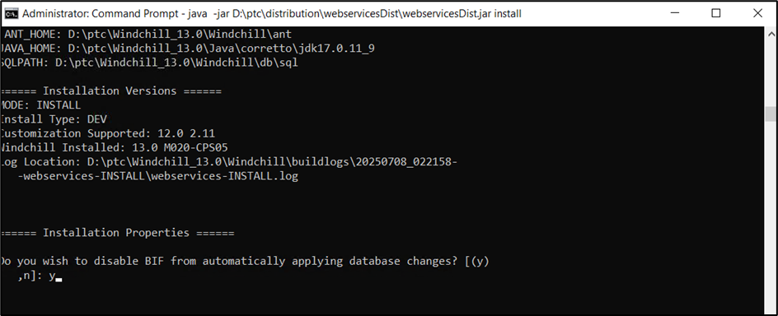

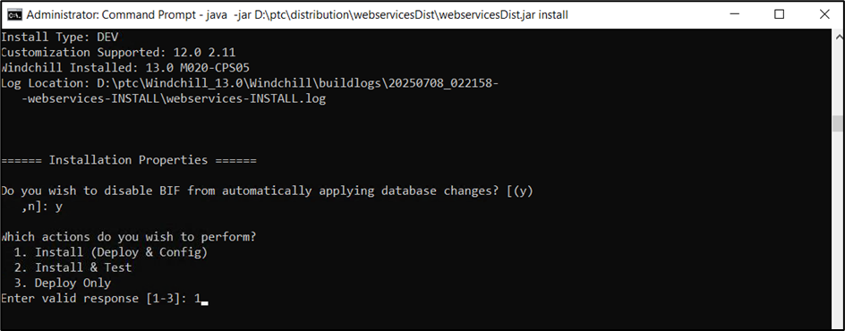

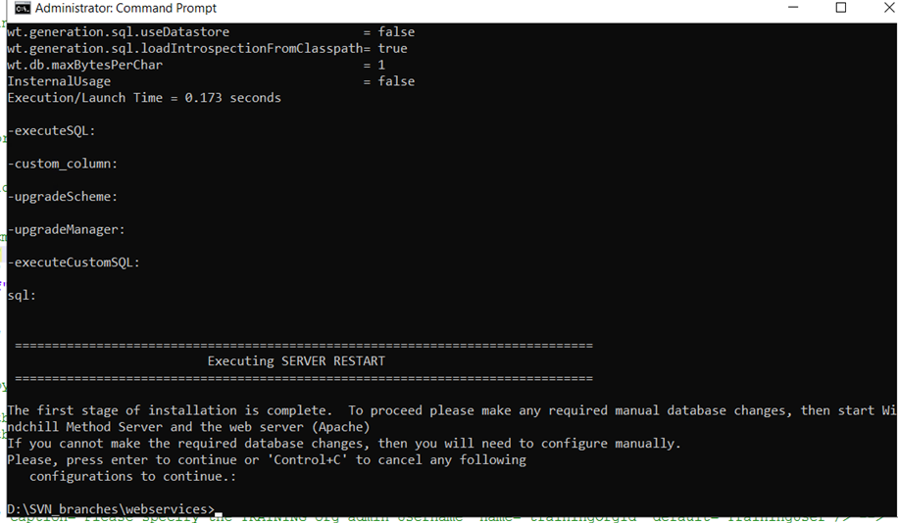

* Open Command shell and navigate to location “D:\SVN_branches\ segmentation” and run below command

*java -jar srclib\BIFSDK-2.1.1.02.jar dist*

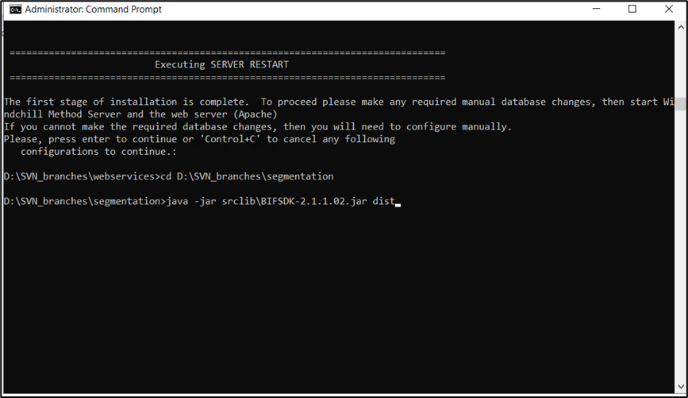

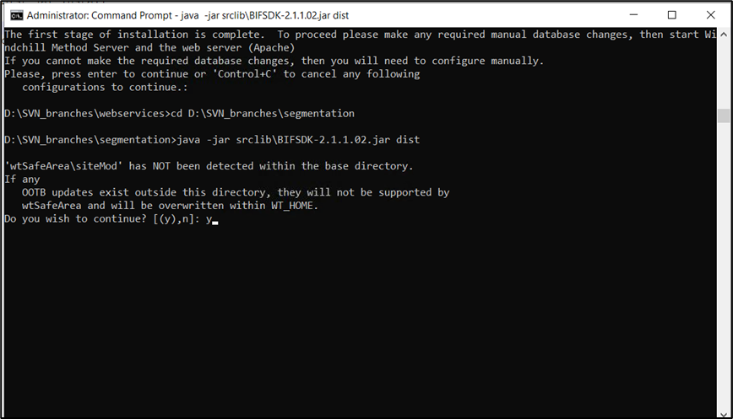

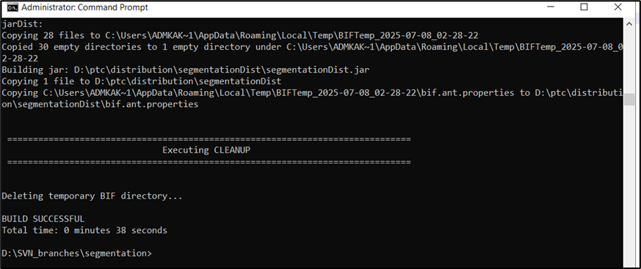

*java -jar D:\ptc\distribution\segmentationDist\segmentationDist.jar install*

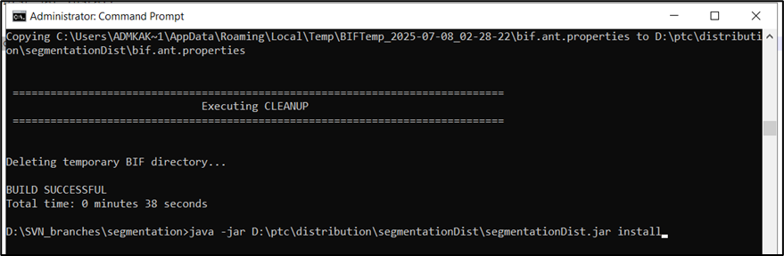

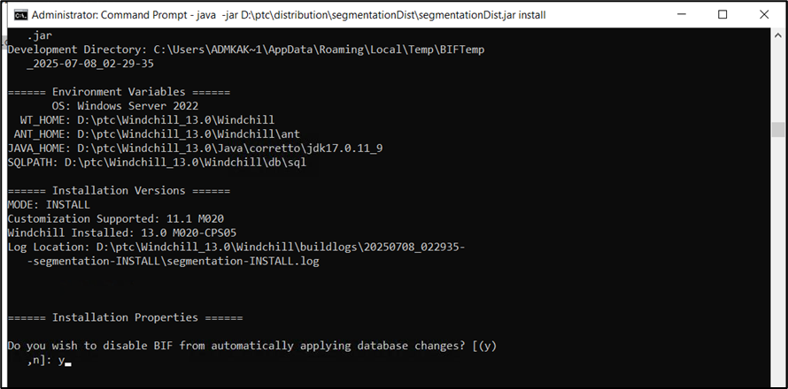

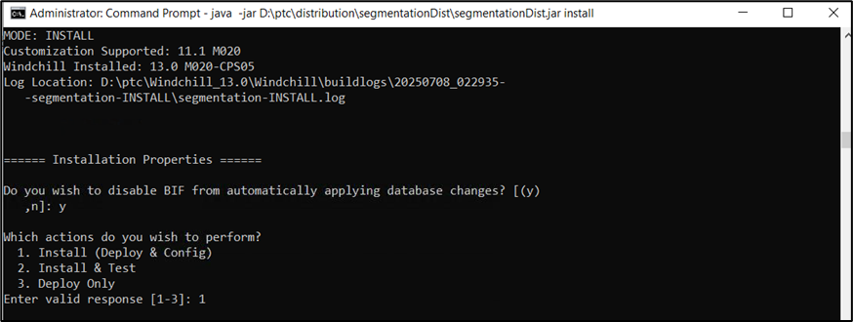

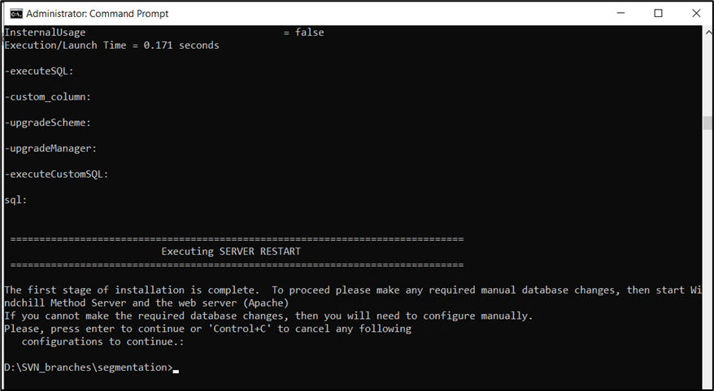

* Open Command shell and navigate to location “D:\SVN_branches\ sap” and run below command

*java -jar srclib\BIFSDK-2.1.1.02.jar dist*

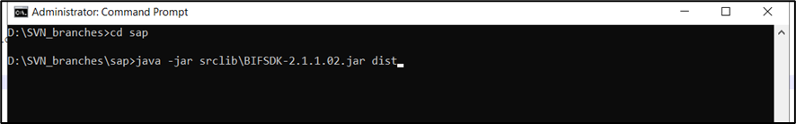

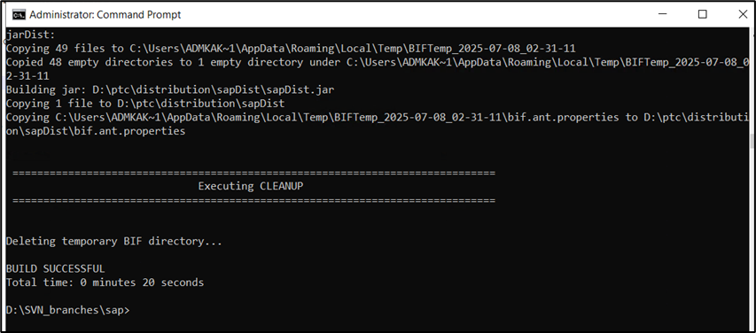

*java -jar D:\ptc\distribution\sapDist\sapDist.jar install*

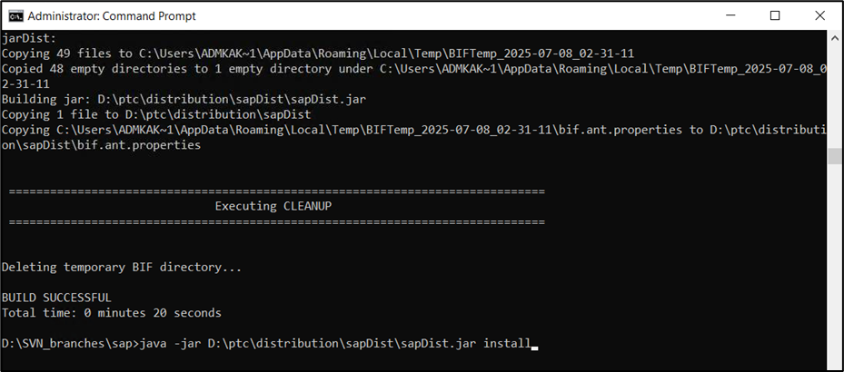

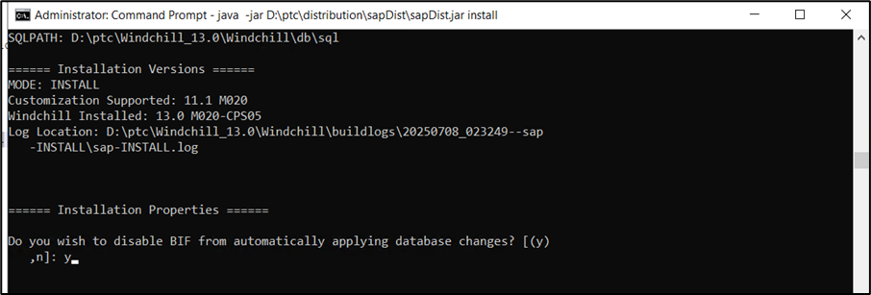

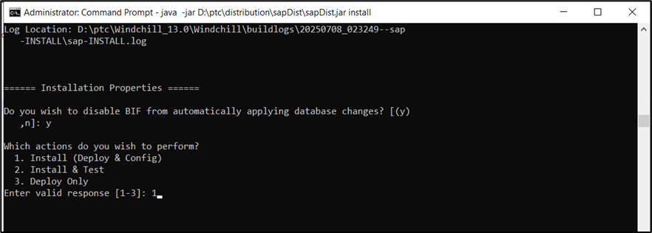

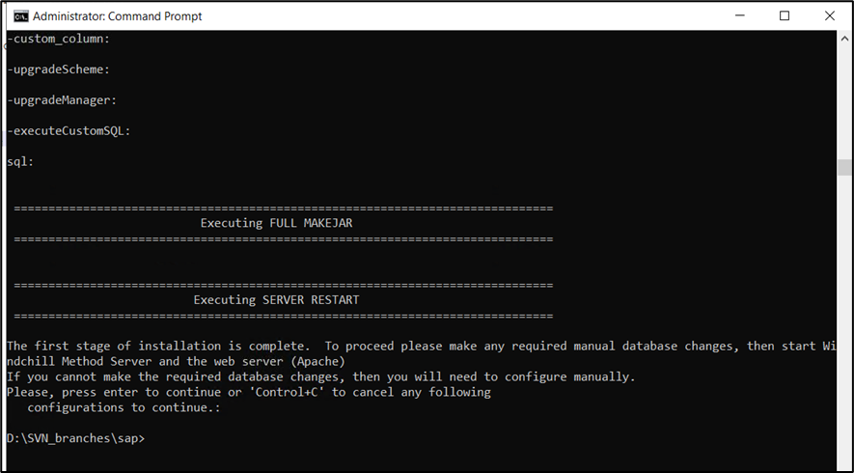

* Open Command shell and navigate to location “D:\SVN_branches\ crdrelease” and run below command

*java -jar srclib\BIFSDK-2.1.1.02.jar dist*

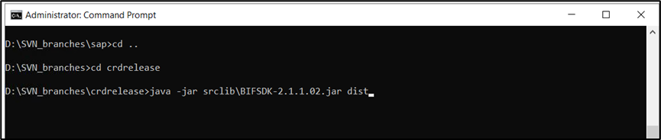

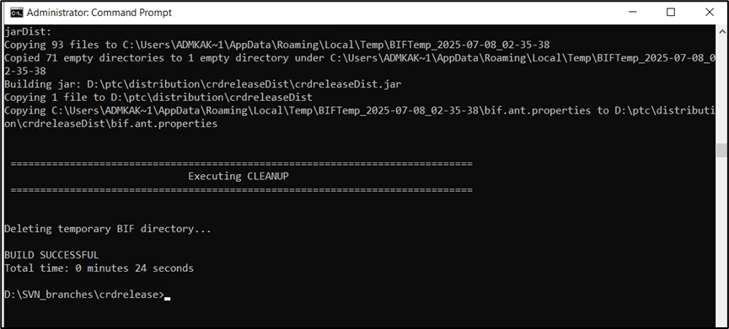

*java -jar D:\ptc\distribution*crdrelease*Dist*crdrelease*Dist.jar install*

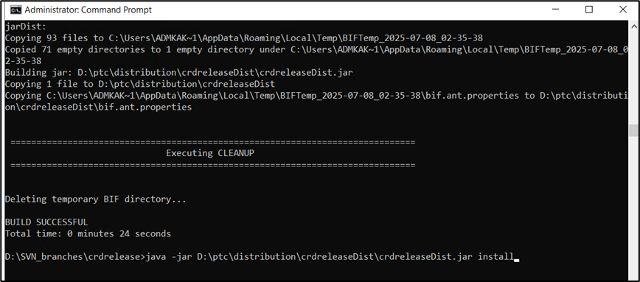

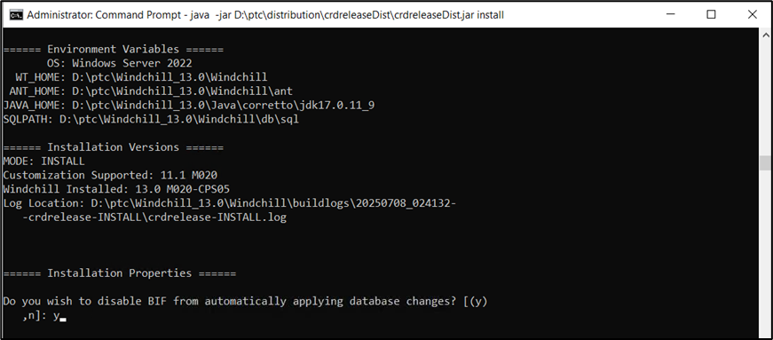

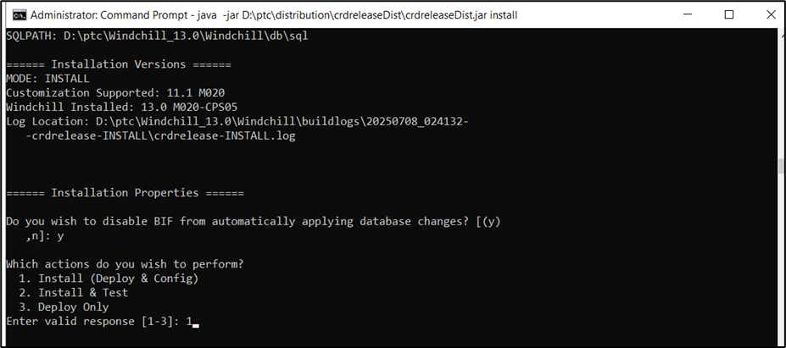

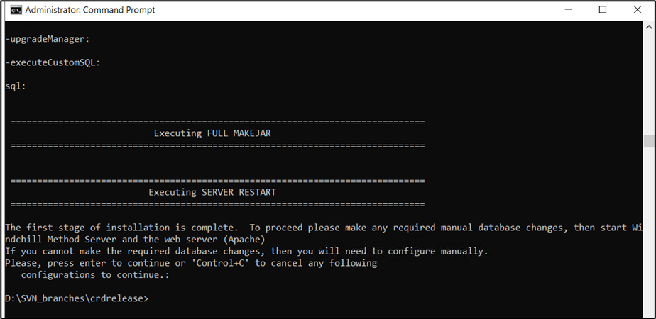

* Open Command shell and navigate to location “D:\SVN_branches\admtools” and run below command

*java -jar srclib\BIFSDK-2.1.1.02.jar dist*

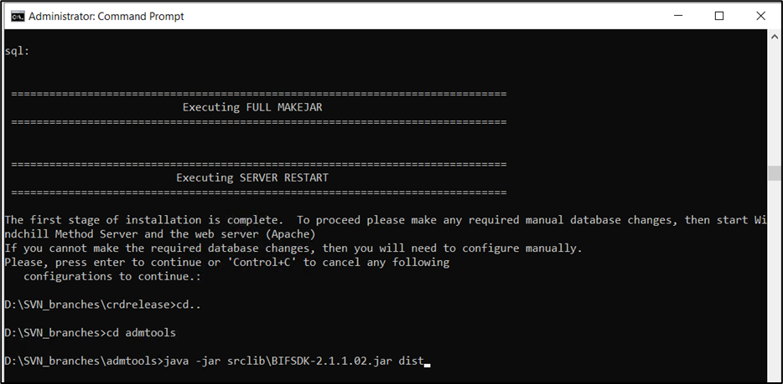

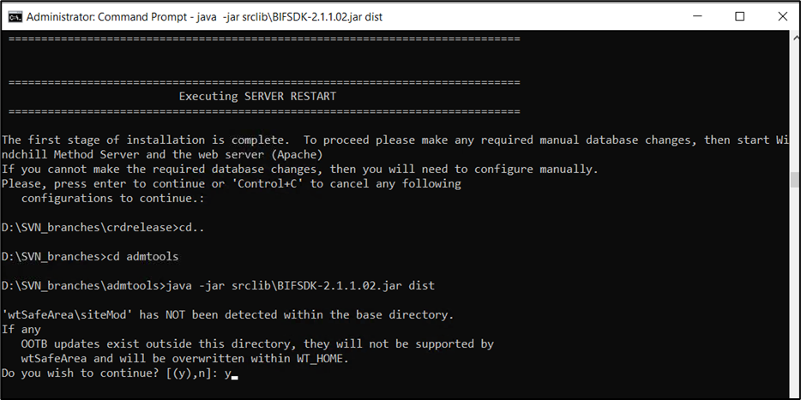

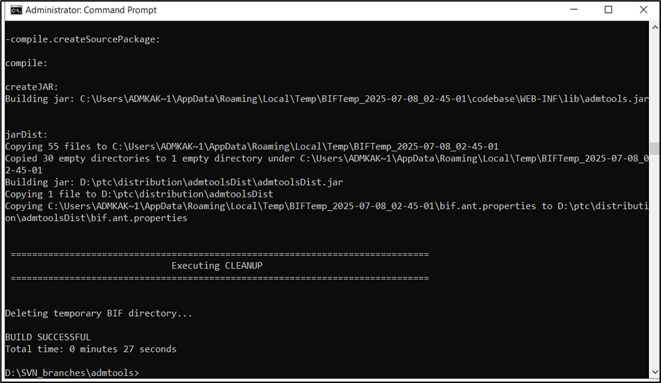

*java -jar D:\ptc\distribution\admtoolsDist\admtoolsDist.jar install*

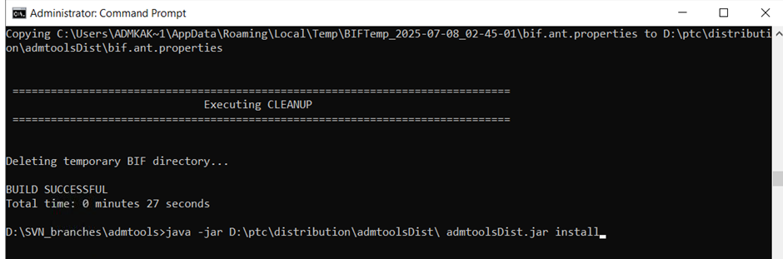

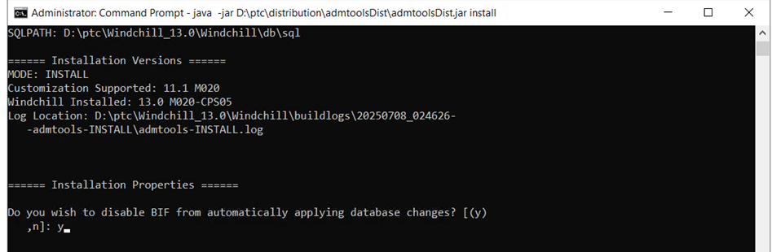

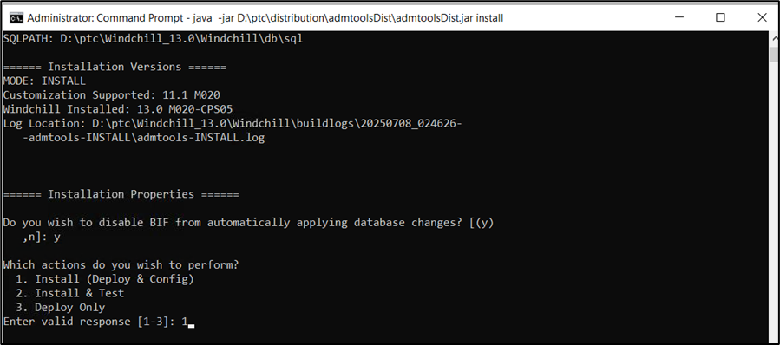

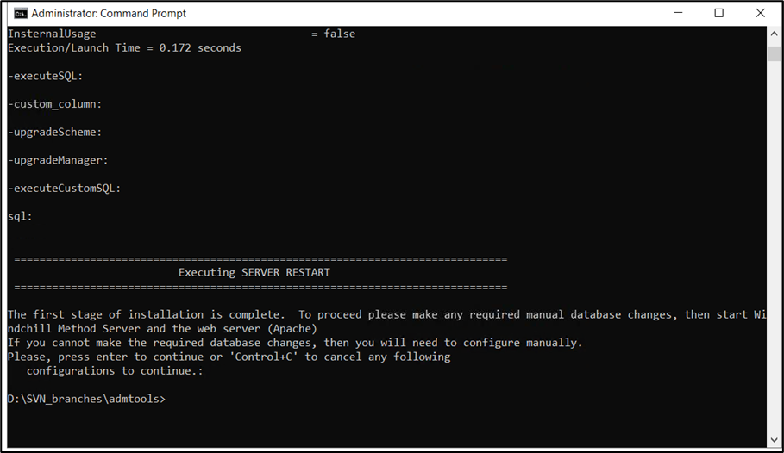

* Open Command shell and navigate to location “D:\SVN_branches\ cms” and run below command

*java -jar srclib\BIFSDK-2.1.1.02.jar dist*

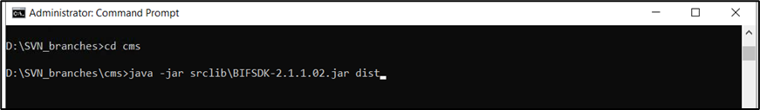

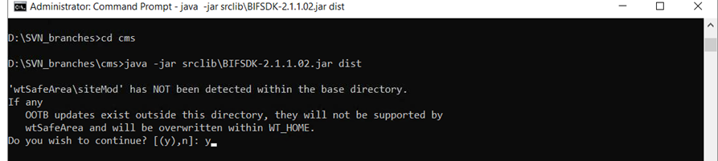

*java -jar D:\ptc\distribution\cmsDist\cmsDist.jar install*

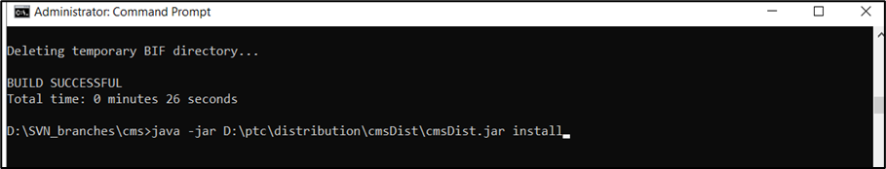

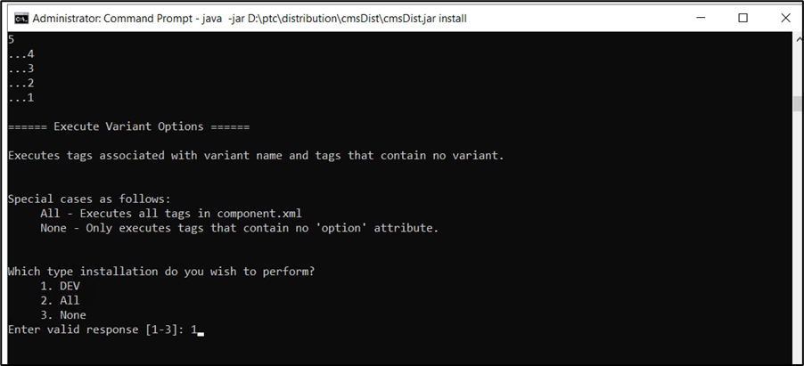

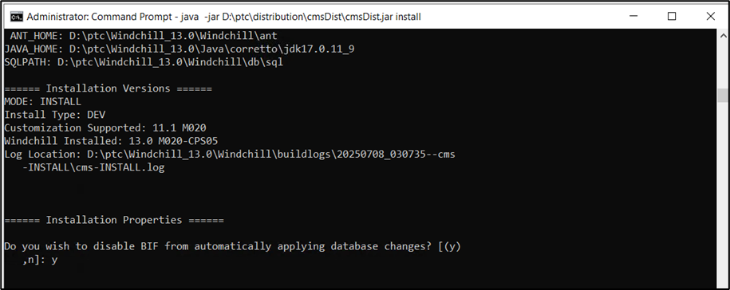

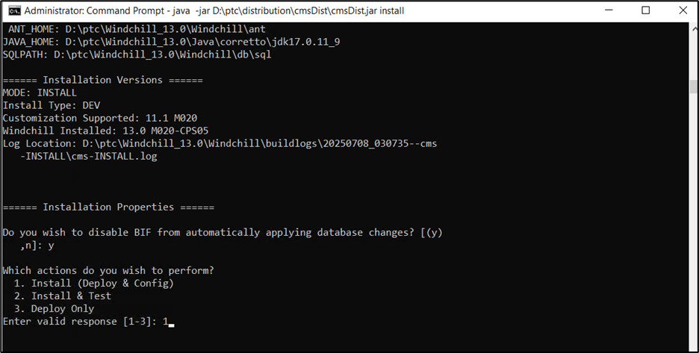

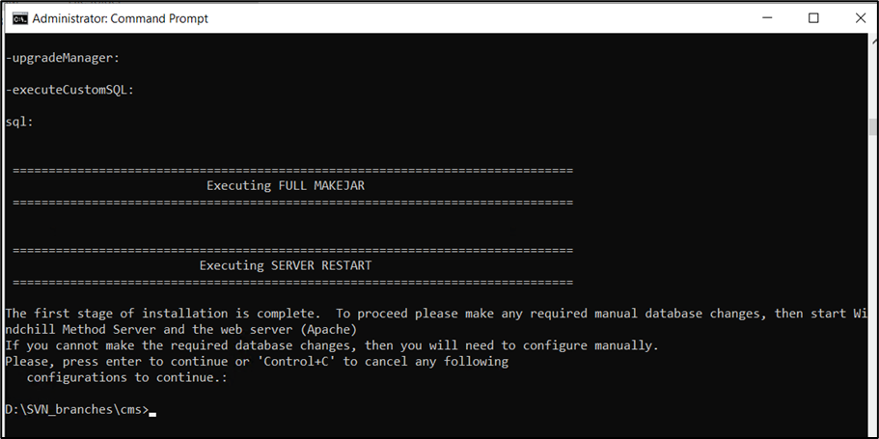

* Open Command shell and navigate to location “D:\SVN_branches\ configmgmt” and run below command

*java -jar srclib\BIFSDK-2.1.1.02.jar dist*

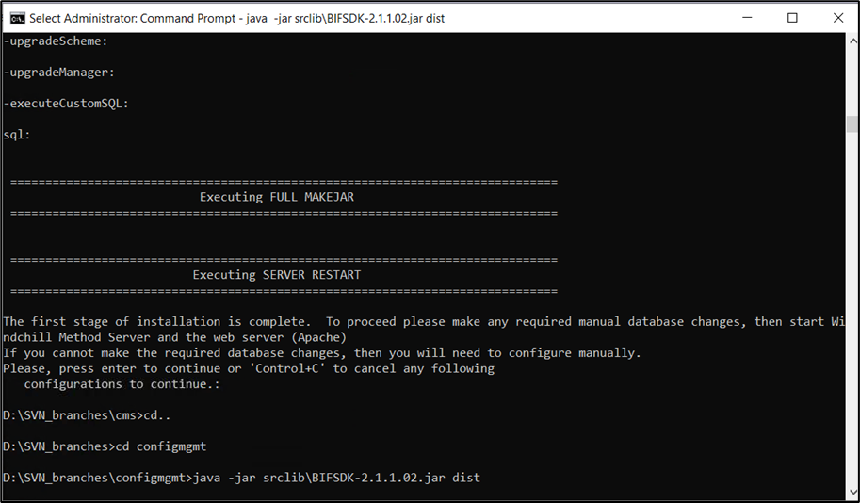

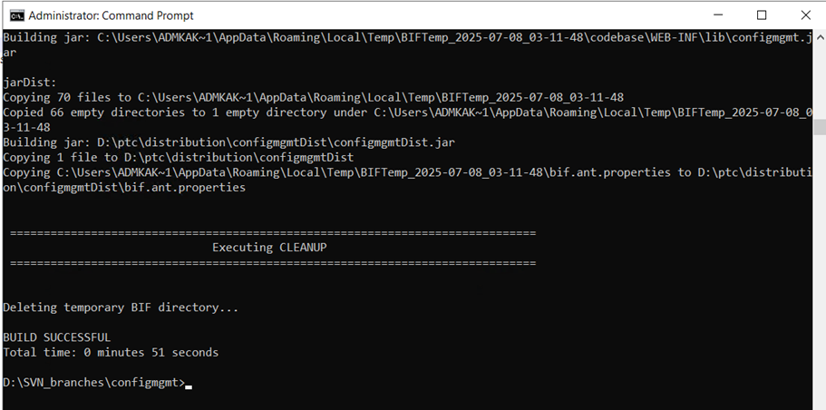

*java -jar D:\ptc\distribution*configmgmt*Dist*configmgmt*Dist.jar install*

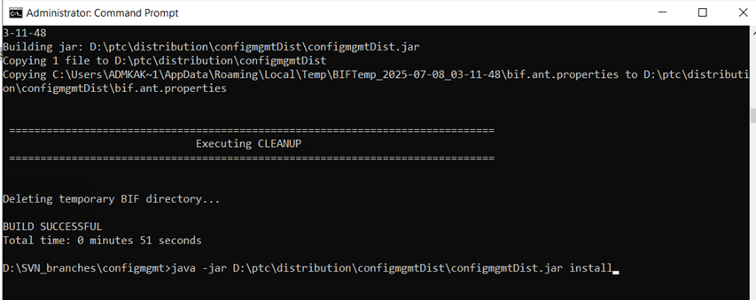

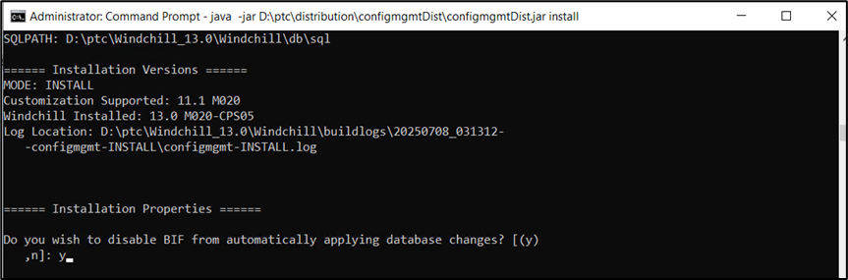

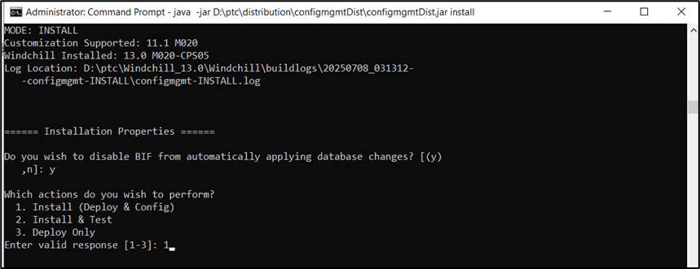

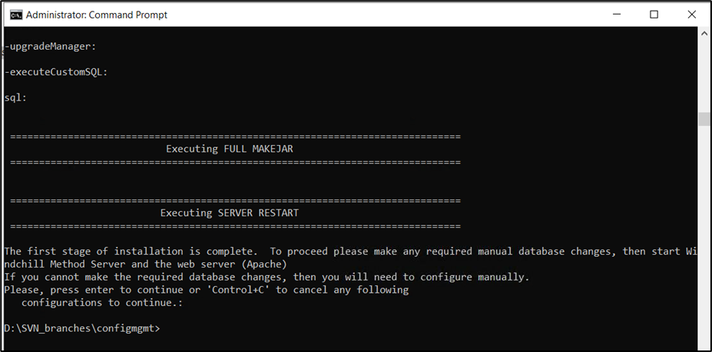

* Open Command shell and navigate to location “D:\SVN_branches\collision\collisiondetection” and run below command

*java -jar srclib\BIFSDK-2.1.1.02.jar dist*

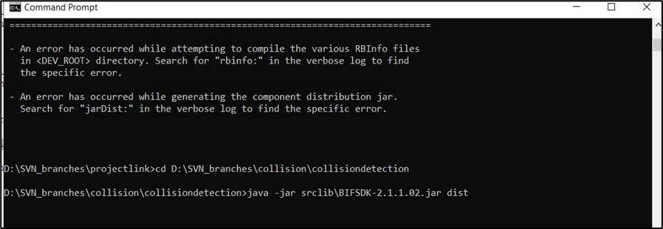

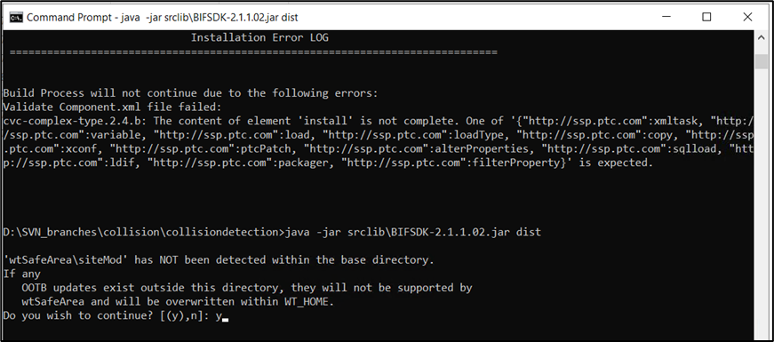

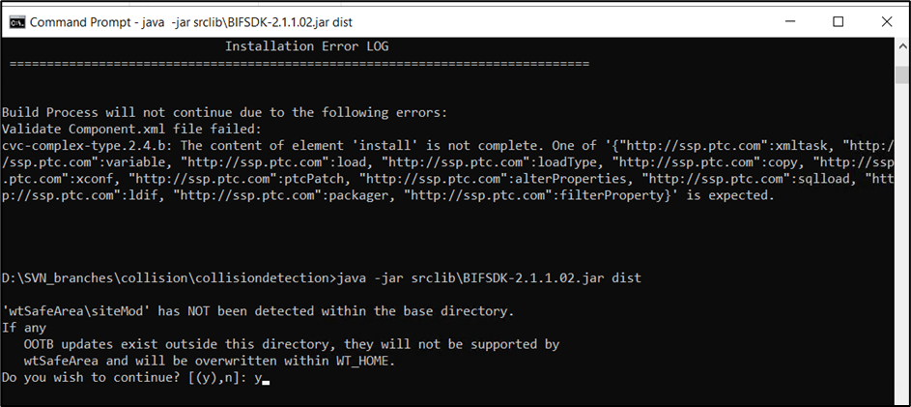

*java -jar D:\ptc\distribution*collision*Dist*collision*Dist.jar install*

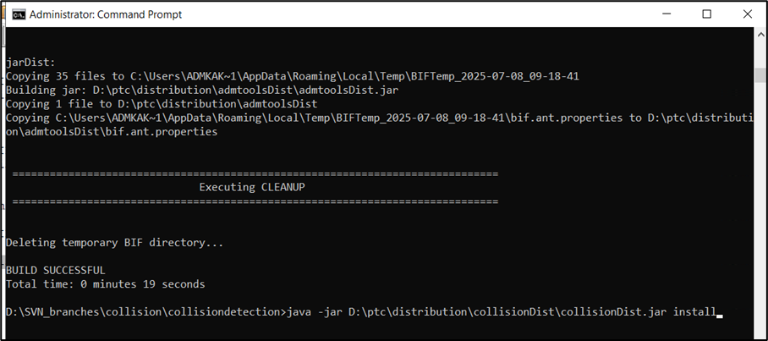

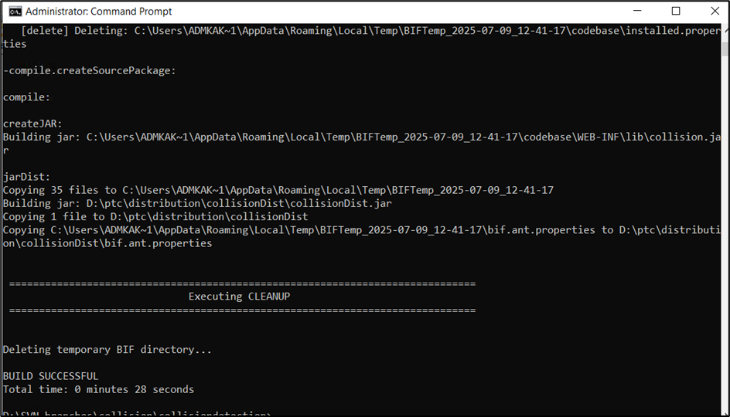

*java -jar D:\ptc\distribution\collisionDist\collisionDist.jar install*

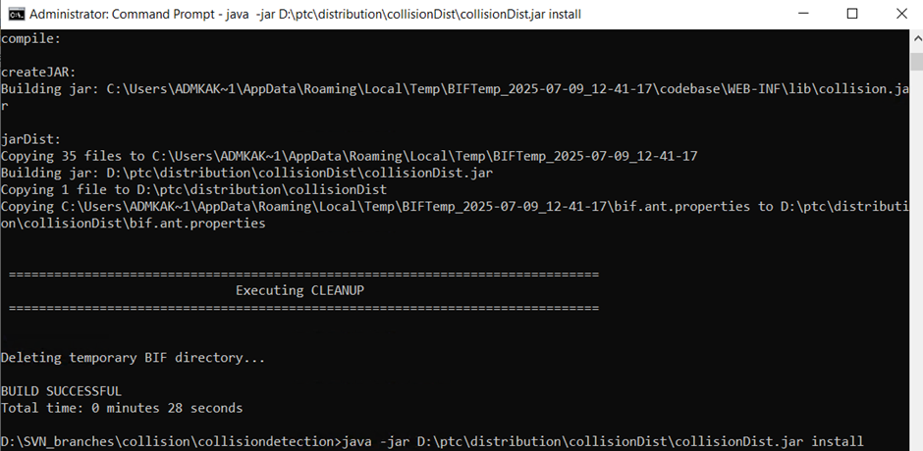

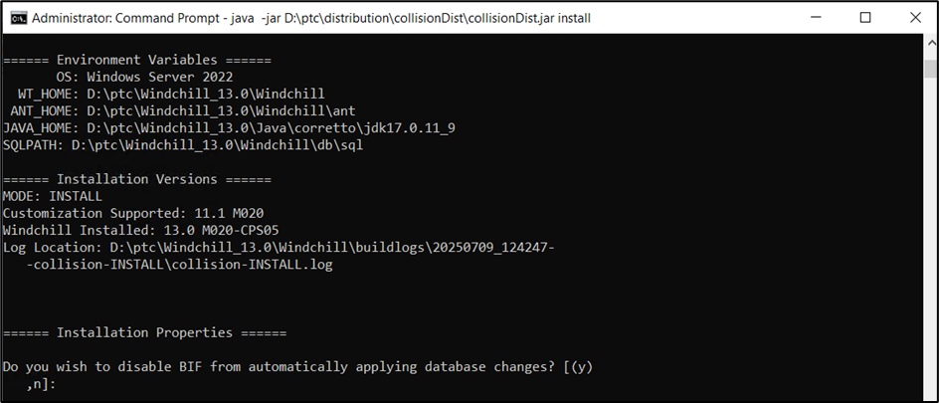

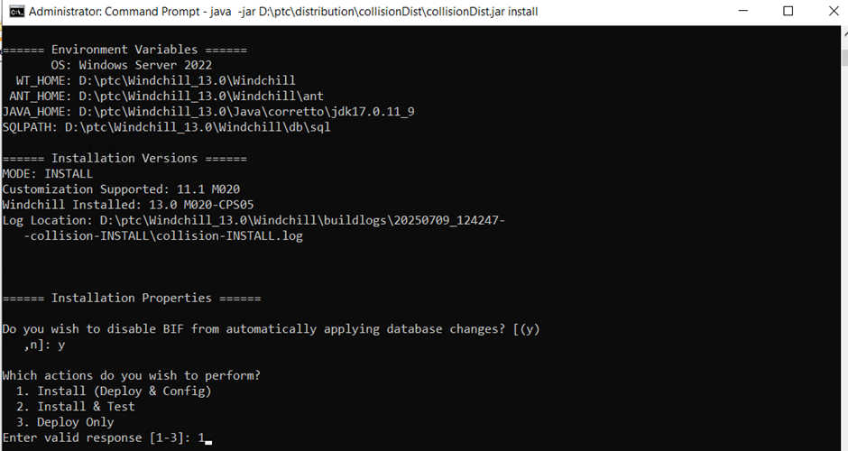

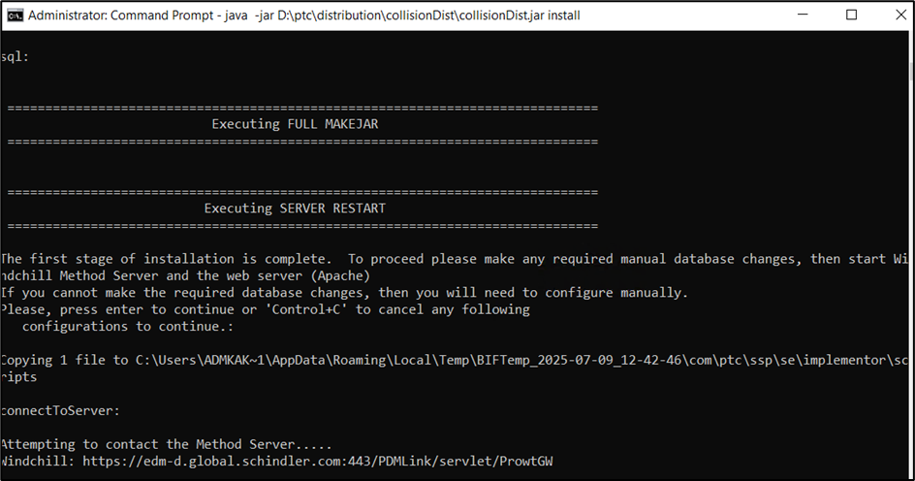

* Open Command shell and navigate to location “D:\SVN_branches\ configmgmt” and run below command

*java -jar srclib\BIFSDK-2.1.1.02.jar dist*

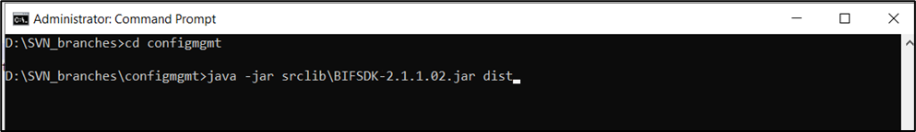

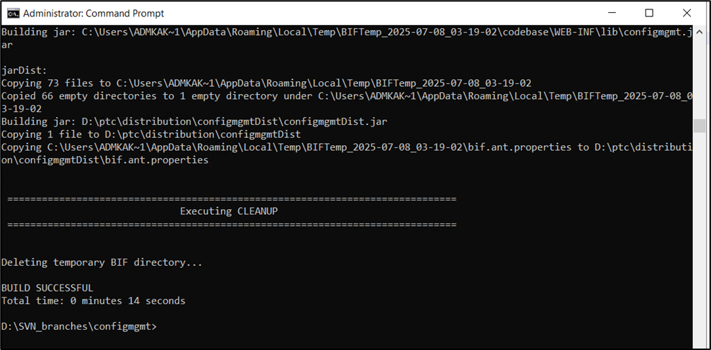

*java -jar D:\ptc\distribution*configmgmt*Dist*configmgmt*Dist.jar install*

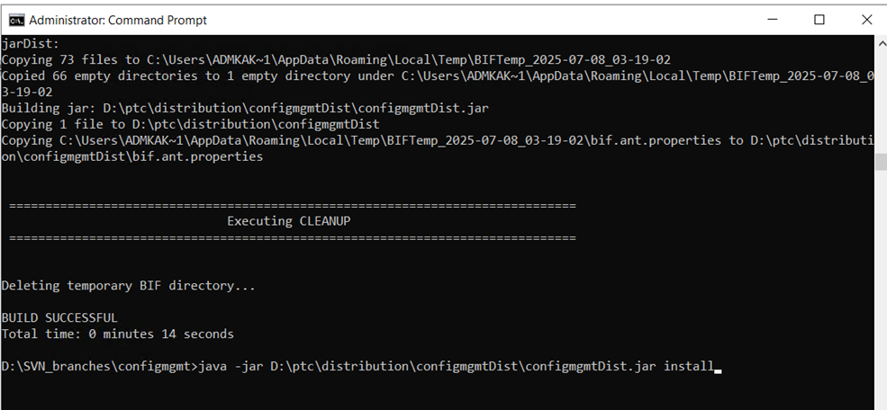

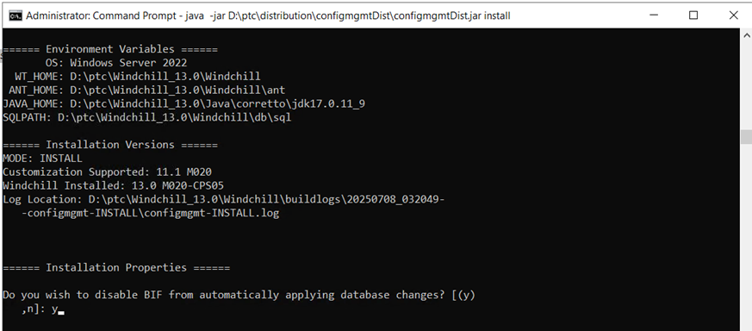

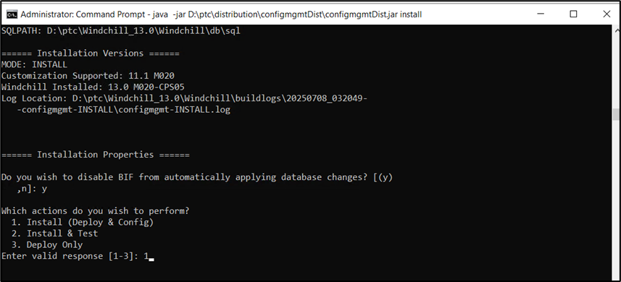

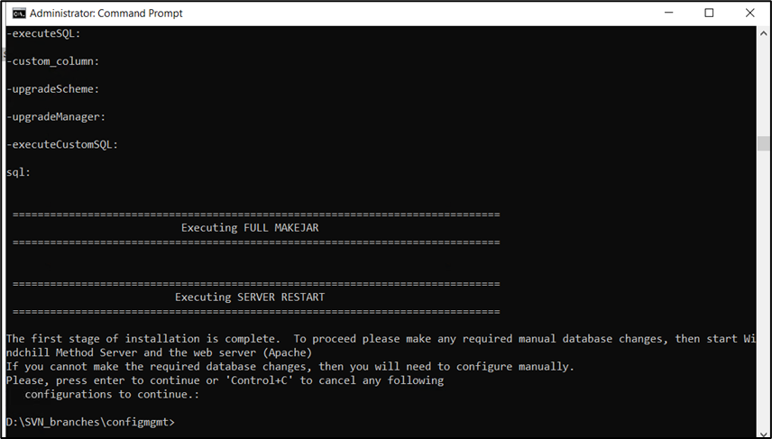

# Common Package Deployment

* Copy schindler.xconf to <WC_HOME>

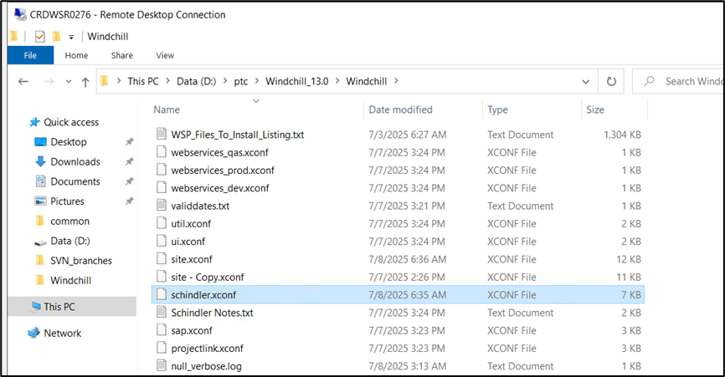

* Copy validdates.txt from D:\SVN_branches\common to <WC_HOME>

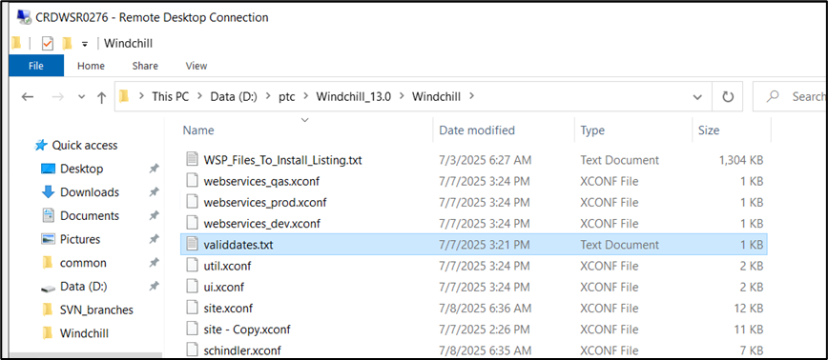

* Copy validdates.txt from D:\SVN_branches\common\codebase to <WC_HOME>\codebase

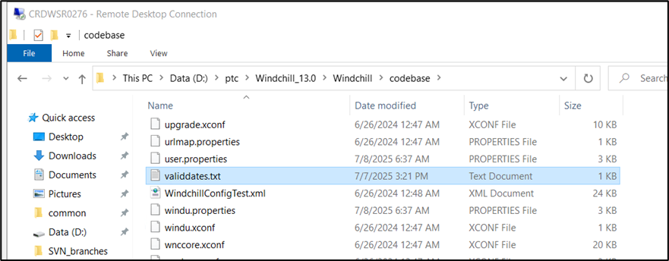

* Update below entries in site.xconf

**<Property name="wt.org.initial.uniquenesslevel" overridable="true"**  
**targetFile="codebase/wt.properties"**  
**value="SITE_LEVEL"/>**

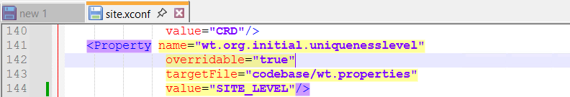

* Add below entries in site.xconf

<ConfigurationRef xlink:href="util.xconf"/>  
<ConfigurationRef xlink:href="ui.xconf"/>  
<ConfigurationRef xlink:href="projectlink.xconf"/>  
<ConfigurationRef xlink:href="webservices_dev.xconf"/>  
<ConfigurationRef xlink:href="sap.xconf"/>  
<ConfigurationRef xlink:href="crdrelease.xconf"/>  
<ConfigurationRef xlink:href="cms_dev.xconf"/>  
<ConfigurationRef xlink:href="configmgt.xconf"/>  
<ConfigurationRef xlink:href="schindler.xconf"/>  
<ConfigurationRef xlink:href="customXconf/lotusNotesEntry.xconf "/>

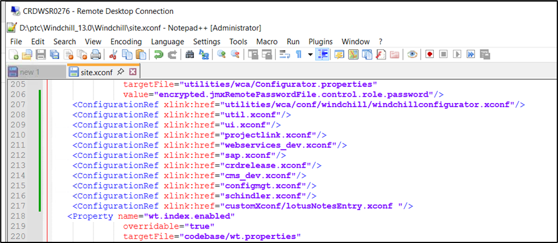

**_dev** is for Development server  
**_qas** is for QA server  
**_prod** is for Production server

Run xconfmanager -p

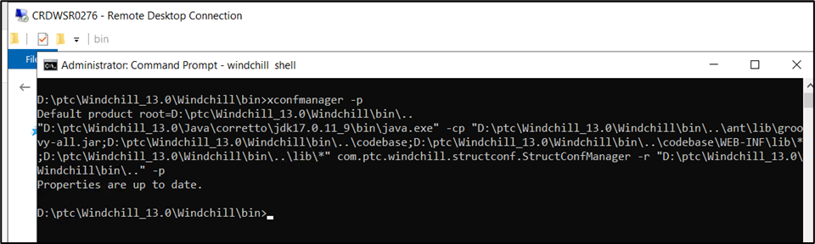

* Copy EPMDocReport.java from D:\SVN_branches\common\src\ext\schindler to <WC_HOME>src/ext/Schindler

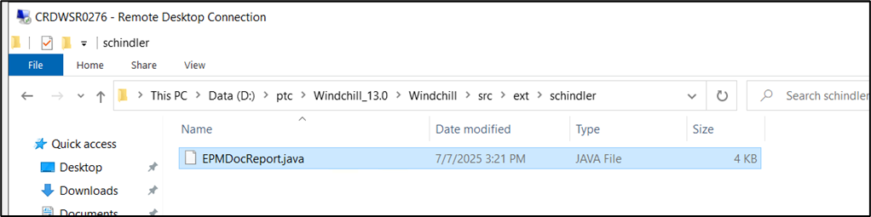

* Compile java file using below command

ant -f bin/tools.xml class -Dclass.source=D:\ptc\Windchill_13.0\Windchill\src\ext\schindler\ -Dclass.includes= EPMDocReport.java -Dclass.force=true

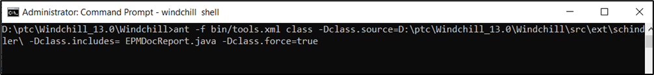

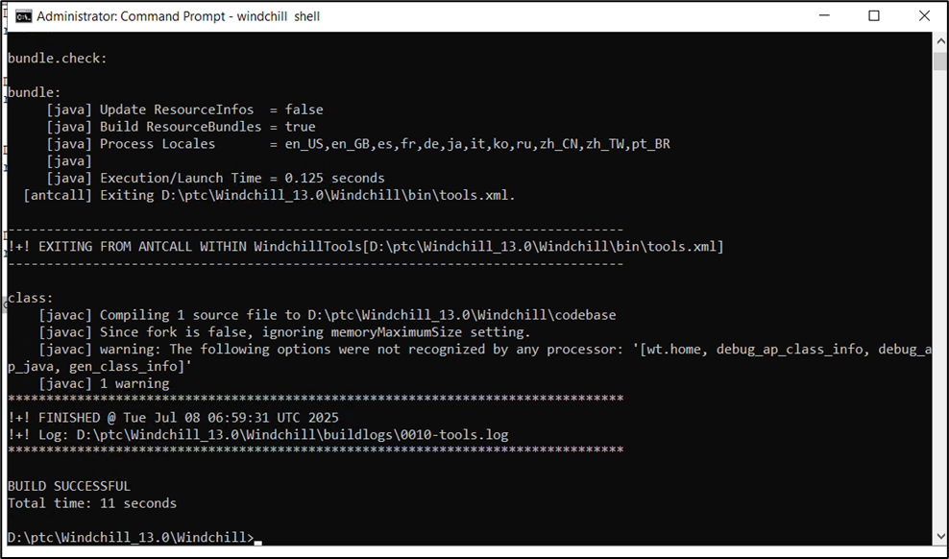

* Validate .class file is generated under codebase

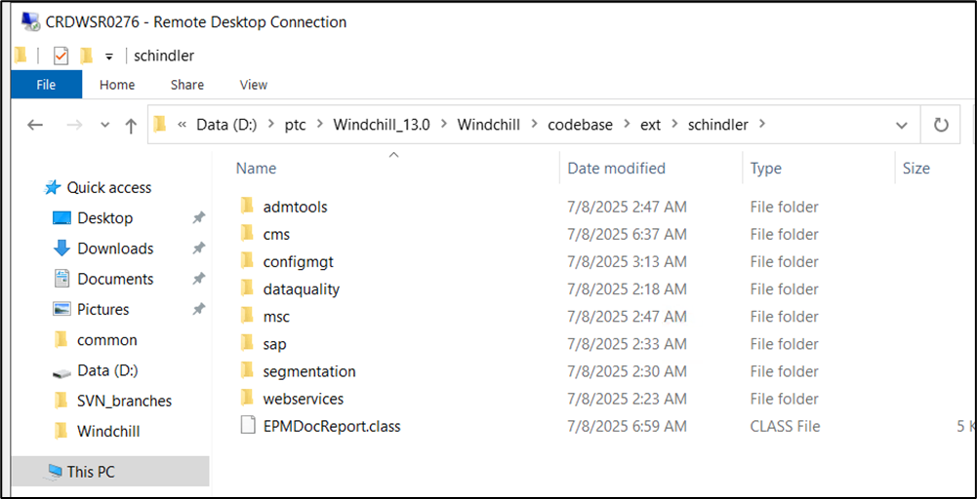

* Add below entry in declaration.xconf

**<ConfigurationRef xlink:href="codebase/ext/schindler/cms/translation/jms/jms.xconf"/>**

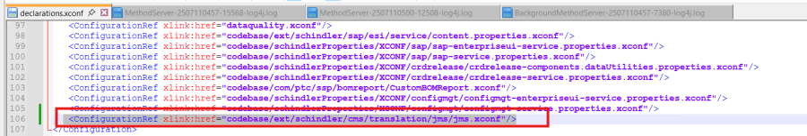

# Update Environment Specific Properties

* Update <WC_HOME>\codebase\ext\schindler\cms\translation\jms\jms.xconf

|  |  |  |  |  |
| --- | --- | --- | --- | --- |
|  | **Property Name** | **Development** | **QAS** | **Production** |
| 1 | ext.schindler.cms.translation.SftpUsername | windchill | windchill | windchill |
| 2 | ext.schindler.cms.translation.SftpPassword | **<Password>** | **<Password>** | **<Password>** |
| 3 | ext.schindler.cms.translation.SftpHostname | shhlsr0375.dmz2.schindler.com:22 | shhlsr0374.dmz2.schindler.com:22 | shhlsr0376.dmz2.schindler.com:22 |

* Update <WC_HOME>\codebase\ext\schindler\sap\esi\service\content.properties.xconf

|  |  |  |  |  |
| --- | --- | --- | --- | --- |
|  | **Property Name** | **Development** | **QAS** | **Production** |
| 1 | ext.schindler.sap.esi.service.content.ftpRemoteFolder | D_WC_SAP_PDM/FT | Q_WC_SAP_PDM/FT | P_WC_SAP_PDM/FT |
| 2 | ext.schindler.sap.esi.service.content.ftpPort | 21 | 21 | 21 |
| 3 | ext.schindler.sap.esi.service.content.ftpHost | crdftp.schindler.com | shhwsr2496.global.schindler.com | crdftp.schindler.com |
| 4 | ext.schindler.sap.esi.service.content.ftpUser | dwic4ws | qwic4ws | pwic4ws |
| 5 | ext.schindler.sap.esi.service.content.ftpPassword | **<Password>** | **<Password>** | **<Password>** |
| 6 | ext.schindler.sap.esi.service.content.ftpIsSecured | false | false | false |

* Update <WC_HOME>\codebase\ext\schindler\cms\schindler_cms.properties

|  |  |  |  |  |
| --- | --- | --- | --- | --- |
|  | **Property Name** | **Development** | **QAS** | **Production** |
| 1 | ext.ptc.schindler.pnc.webservice.endpointaddress | https\://infwdt31.inf.schindler.com/sap/bc/srt/rfc/sap/ztpzp_ad_dcminf_rdychkin_check/672/ztpzp_ad_dcminf_rdychkin_check/ztpzp_ad_dcminf_rdychkin_checkbinding | https\://infwdc31.inf.schindler.com/sap/bc/srt/rfc/sap/ztpzp_ad_dcminf_rdychkin_check/670/ztpzp_ad_dcminf_rdychkin_check/ztpzp_ad_dcminf_rdychkin_checkbinding | http\://infwdeu1.inf.schindler.com/sap/bc/srt/rfc/sap/ztpzp_ad_dcminf_rdychkin_check/670/ztpzp_ad_dcminf_rdychkin_check/ztpzp_ad_dcminf_rdychkin_checkbinding |
| 2 | ext.ptc.schindler.pnc.webservice.username | DPTCWCPDM | QPTCWCPDM | PPTCWCPDM |
| 3 | ext.ptc.schindler.pnc.webservice.password | **<Password>** | **<Password>** | **<Password>** |

* Update <WC_HOME>\tasks\ext\schindler\cms\translation\jms\sendJmsMessage.xml

|  |  |  |  |  |
| --- | --- | --- | --- | --- |
|  | **Property Name** | **Development** | **QAS** | **Production** |
| 1 | param name="service | <ie:param name="service" data="com.schindler.global.edm-d.jmsService" /> | <ie:param name="service" data="com.schindler.global.edmq.jmsService" /> | <ie:param name="service" data="com.schindler.global.edm.jmsService" /> |

* Update <WC_HOME>\tasks\ext\schindler\cms\translation\jms\ subscribeQueue.xml

|  |  |  |  |  |
| --- | --- | --- | --- | --- |
|  | **Property Name** | **Development** | **QAS** | **Production** |
| 1 | param name="service | <ie:param name="service" data="com.schindler.global.edm-d.jmsService" /> | <ie:param name="service" data="com.schindler.global.edmq.jmsService" /> | <ie:param name="service" data="com.schindler.global.edm.jmsService" /> |

* Update wt.mail.from property in schindler.xconf as per below
  1. Dev - [crd_edm_dev@schindler.com](mailto:crd_edm_dev@schindler.com)
  2. QA - [crd_edm_qas@schindler.com](mailto:crd_edm_qas@schindler.com)
  3. PROD - [crd_edm_prod@schindler.com](mailto:crd_edm_prod@schindler.com)

# Lotus Deployment

* **Property Files:**

**Create folder structure <Windchill Home>\codebase\com\schindler\lotusNotesDocument**

|  |  |  |  |
| --- | --- | --- | --- |
| **Sr No** | **Property File Name** | **Purpose** | **Target File Location** |
| 1 | CategoryAttributeValueMapping.properties | Mapping of Category cascading attributes | <Windchill Home>\codebase\com\schindler\lotusNotesDocument |
| 2 | CategoryKeyValue.properties | Internal and display values of all the cascading values | <Windchill Home>\codebase\com\schindler\lotusNotesDocument |
| 3 | ComponentAsssemblyElement.pr operties | Mapping of cascading attributes | \codebase\com\schindler\lotusNotesDocument |
| 4 | KeyValue.properties | Internal and display values of all the cascading values | \codebase\com\schindler\lotusNotesDocument |
| 5 | WindchillCSVConverterProperties. Properties | Using for transformtaion java codes | \codebase\com\schindler\lotusNotesDocument |
| 6 | GetUpdatedProductName.properties |  | \codebase\com\schindler\lotusNotesDocument |

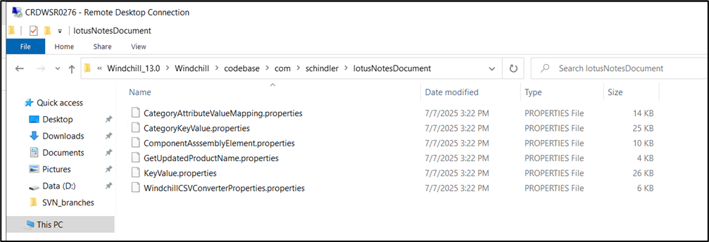

* **xconf File Update**

**Note:** **Enter and register the below Xconf file in Site.xconf**  
**Create folder structure** **<Windchill Home>\customXconf**  
**Add new entry.**

|  |  |  |  |
| --- | --- | --- | --- |
| **Sr No** | **xconf File Name** | **Purpose** | **Target File Location** |
| 1 | lotusNotesEntry.xconf | Registered dataUtility id of cascading attributes | <Windchill Home>\customXconf |

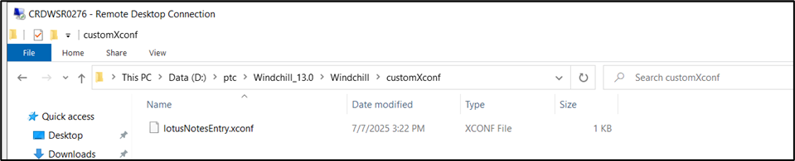

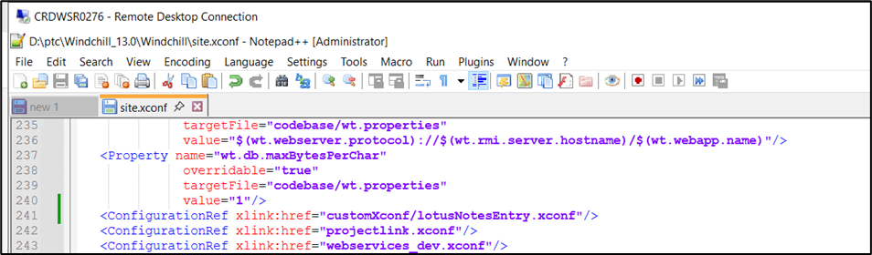

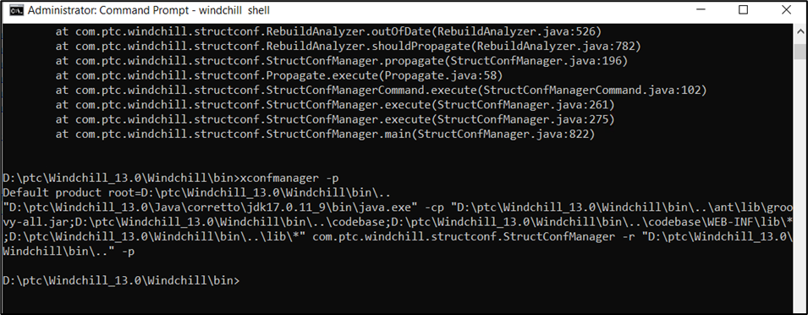

* **JSP File:**

**Create folder structure** **<Windchill Home>\codebase\netmarkets\jsp\custom**

|  |  |  |  |
| --- | --- | --- | --- |
| **Sr No** | **JSP File Name** | **Purpose** | **Target File Location** |
| 1 | LoadCategory.jsp | Code for Category cascading attributes customization | <Windchill Home>\codebase\netmarkets\jsp\custom |
| 2 | loadComponent.jsp | Code for cascading attributes customization | <Windchill Home>\\codebase\netmarkets\jsp\custom |

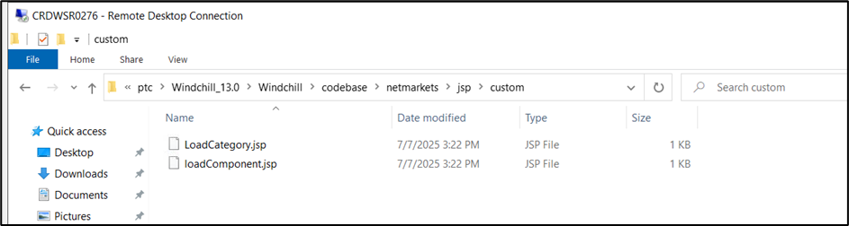

* **JavaScript File:**

Note: Verify javascript code at the end of below mentioned files.  
File 1 : <Windchill Home>\codebase\netmarkets\jsp\document\create.jspf

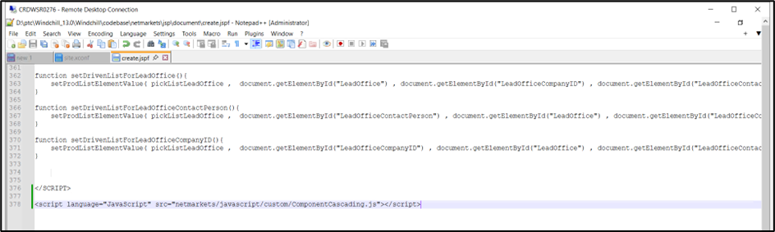

File 2 : <Windchill Home>\codebase\netmarkets\jsp\document\edit.jsp

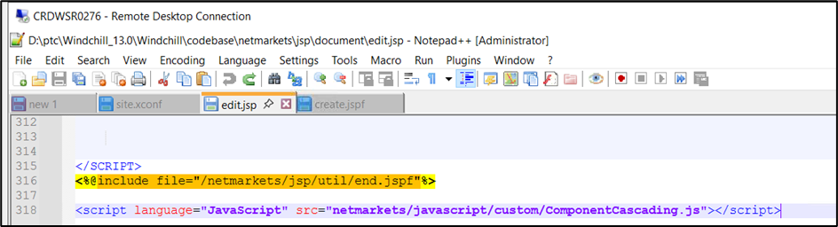

Code: <script language="JavaScript" src="netmarkets/javascript/custom/ComponentCascading.js"></script>

|  |  |  |  |
| --- | --- | --- | --- |
| **Sr No** | **JSP File Name** | **Purpose** | **Target File Location** |
| 1 | ComponentCascading.js | Code for cascading attributes customization | <Windchill Home>\codebase\netmarkets\javascript\custom |

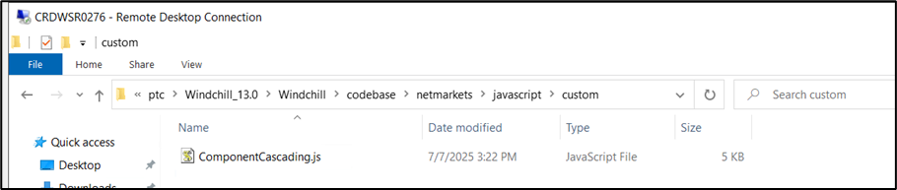

* **Java Files For Cascading Customization:**

**Create folder structure** **<Windchill Home>\src\com\schindler\lotusNotesDocument**

|  |  |  |  |
| --- | --- | --- | --- |
| **Sr No** | **Java File Name** | **Purpose** | **Target File Location** |
| 1 | CategoryDataUtility.java | Code for Category cascading attributes customization | <Windchill Home>\src\com\schindler\lotusNotesDocument |
| 2 | ComponentDataUtility.java | Code for cascading attributes customization | <Windchill Home>\\src\com\schindler\lotusNotesDocument |
| 3 | LotusNotesHelper.java | Helper java for cascading attributes customization | \src\com\schindler\lotusNotesDocument |

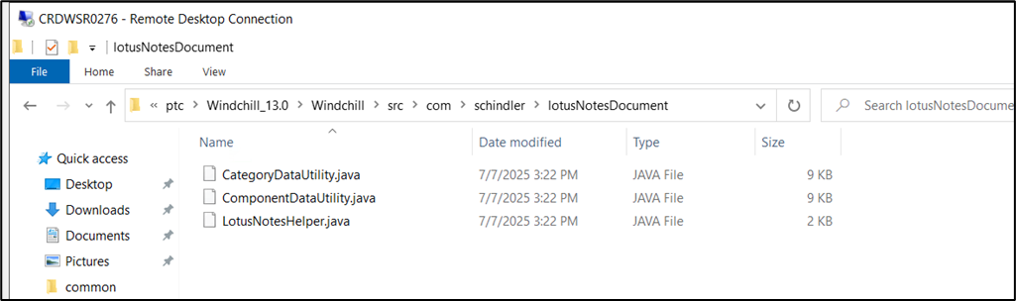

* Run below command to compile   
  ant -f bin/tools.xml class -Dclass.includes=com/schindler/lotusNotesDocument/**

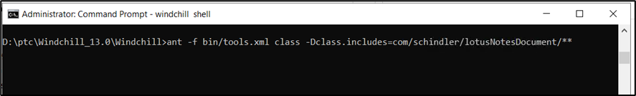

* Validate class files are created

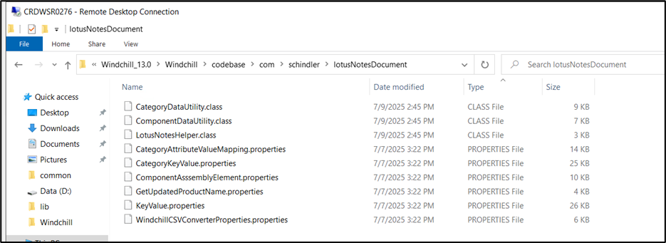

* Run below command from windchill shell:

**ant -f D:\ptc\Windchill_13.0\Windchill\bin\adminTools\sip\EncryptPasswords.xml encryptPw -DpropertyName=ext.schindler.webservices.inventio.auth.password -Dpassword="PASSWORD"**

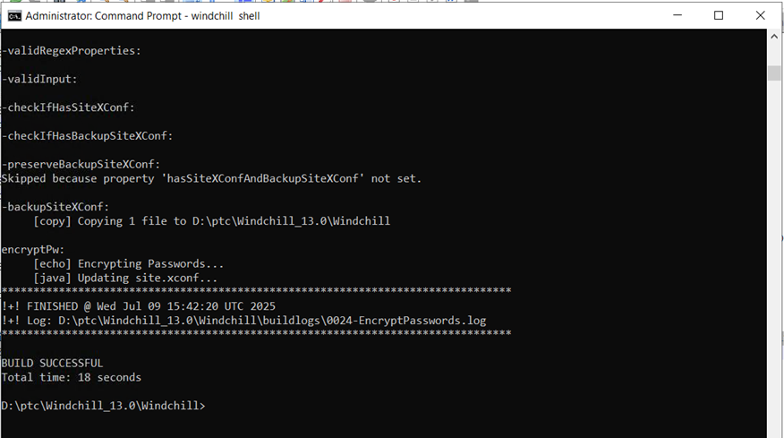

Note: Please refer below table for password in each environment

|  |  |  |  |  |
| --- | --- | --- | --- | --- |
|  | Property Name | Development (DPTCWCPDM) | QAS (QPTCWCPDM) | Production (PPTCWCPDM) |
| 1 | Native data password | **<Password>** | **<Password>** | **<Password>** |

1. Restart windchill clearing all cache

# Post Upgrade Steps

## Create JMS Service

* Login to windchill with site admin access and go to Site → Utilities → Info*Engine Administration and update jms service adapter as shown in below screen shots:

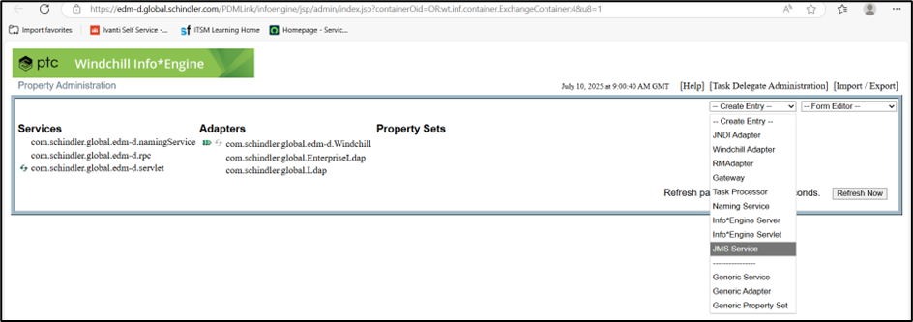

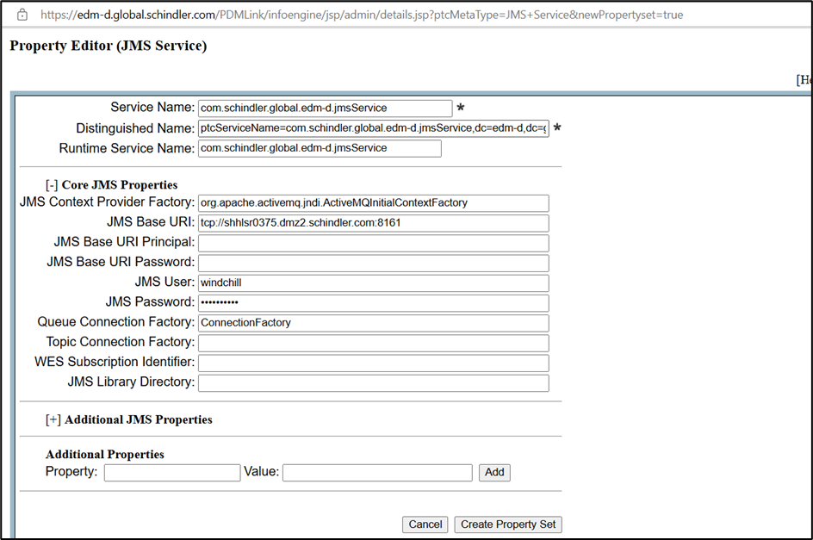

Refer below password for environment  
*Note: Please refer below table for values of JMS Base URI, username and password for each environment*

|  |  |  |  |
| --- | --- | --- | --- |
| Environment | Dev | QA | Prod |
| JMS Base URI | tcp://shhlsr0375.dmz2.schindler.com:8161 | tcp://shhlsr0374.dmz2.schindler.com:8161 | tcp://shhlsr0376.dmz2.schindler.com:8161 |
| JMS User | windchill | windchill | windchill |
| JMS Password | **<Password>** | **<Password>** | **<Password>** |

* Once Service is created then it will be available under Property Sets

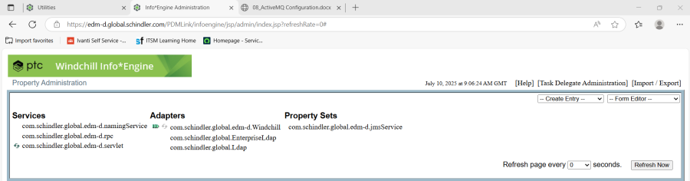

* Click on created Property Set and validate values

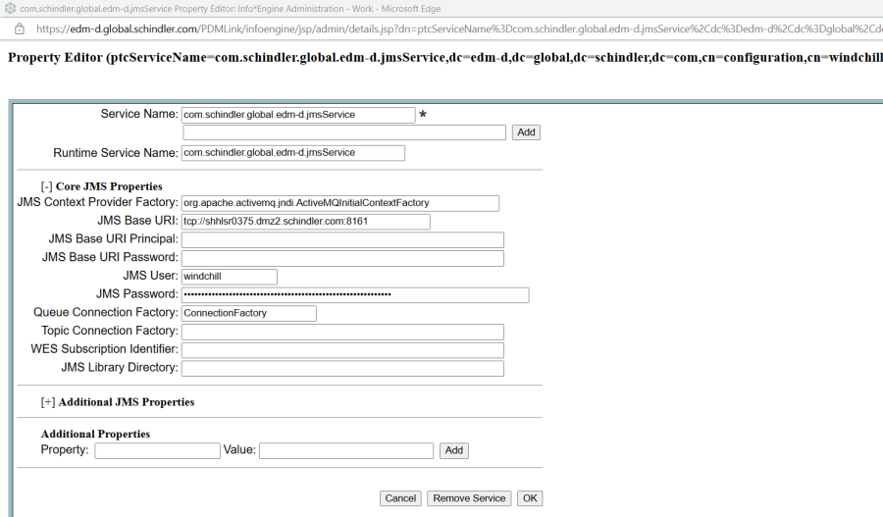

## Update Translation Preferences

1. Update *Translation Support* related preferences and make sure it is matching with source system.

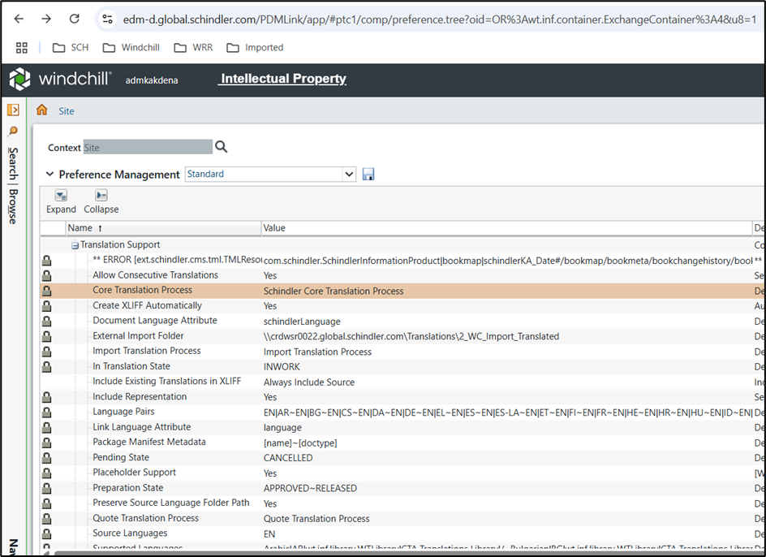

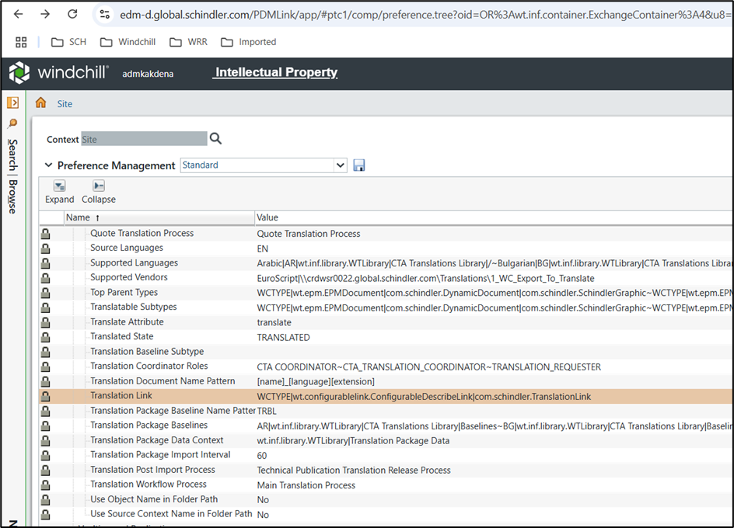

## Update SchindlerCMSArbortextPublishRules

* Navigate to CTA Library > Utilities > Visualization Configuration Administration

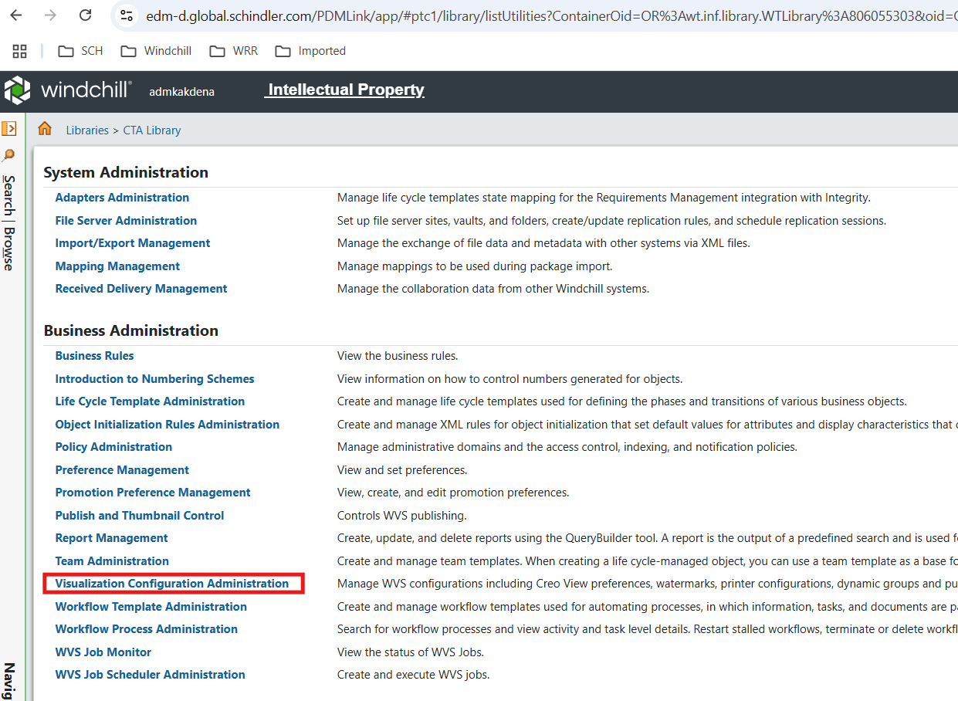

* Select CTA Library

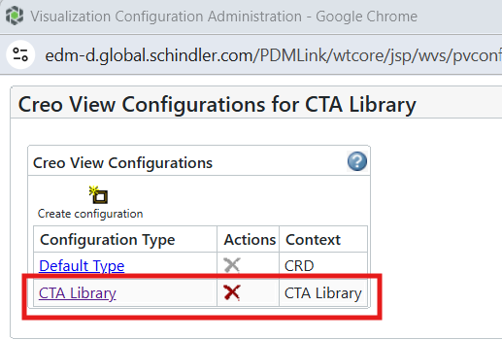

* Download updated SchindlerCMSArbortextPublishRules.xml from attachment

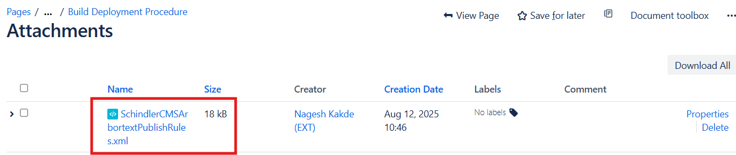

* Delete SchindlerCMSArbortextPublishRules.xml and add file downloaded in previous step

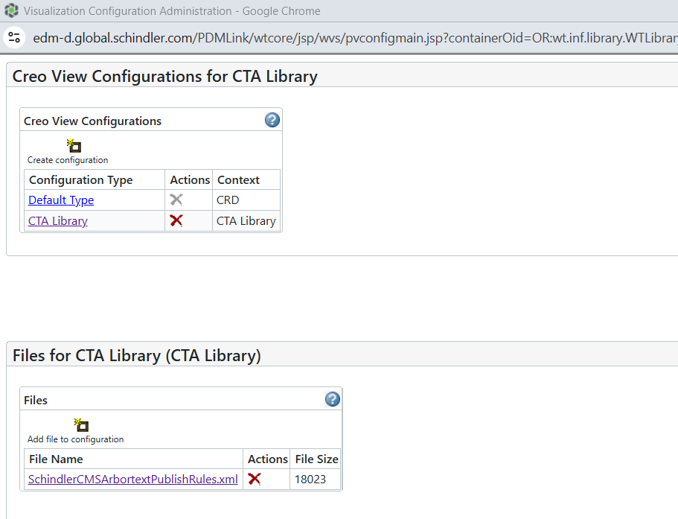

## Update SchindlerCMSArbortextPublishRules - SC7 Product

* Navigate to SC7 Product > Utilities > Visualization Configuration Administration

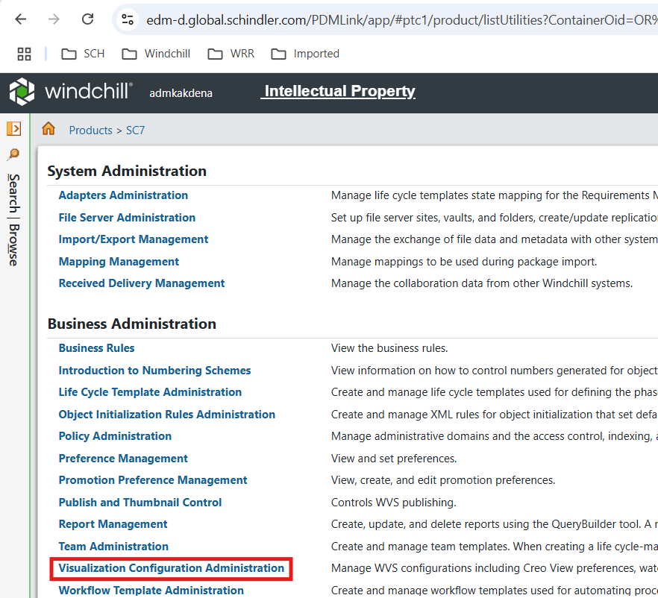

* Download updated SchindlerCMSArbortextPublishRules_SC7.xml from attachment

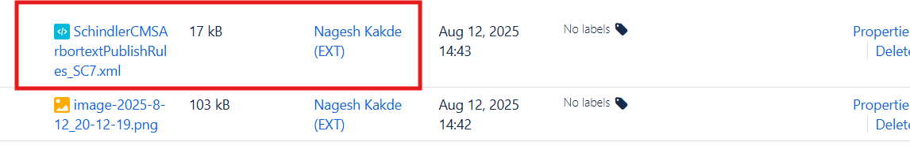

* Delete SchindlerCMSArbortextPublishRules.xml and add file downloaded in previous step after renaming to SchindlerCMSArbortextPublishRules

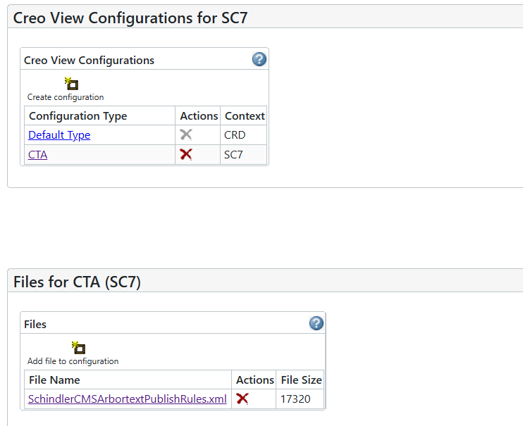

## Update SchindlerCMSTranslationPublishRules

* Navigate to CTA Translations Library > Utilities > Visualization Configuration Administration

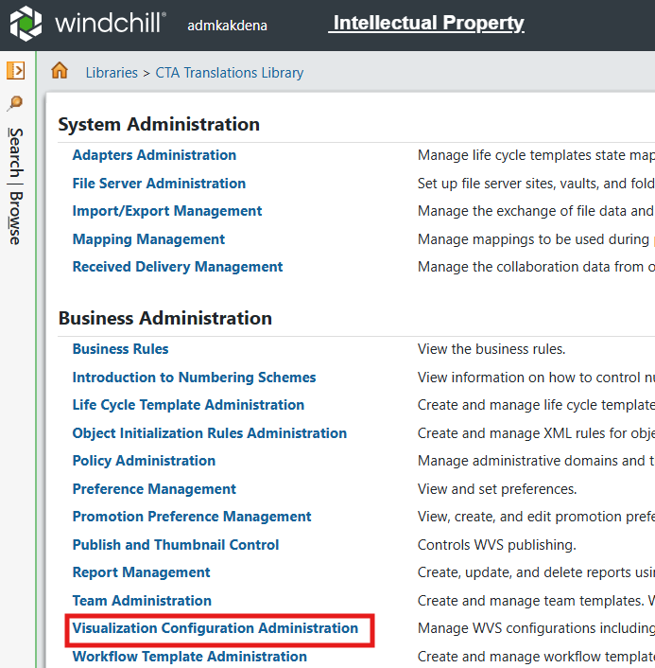

* Select CTA Translation Library

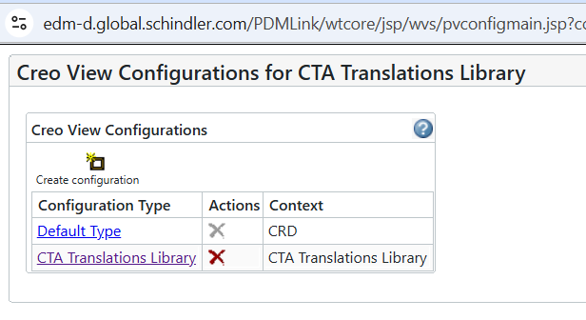

* Download updated SchindlerCMSArbortextPublishRules.xml from attachment



* Delete SchindlerCMSArbortextPublishRules.xml and add file downloaded in previous step

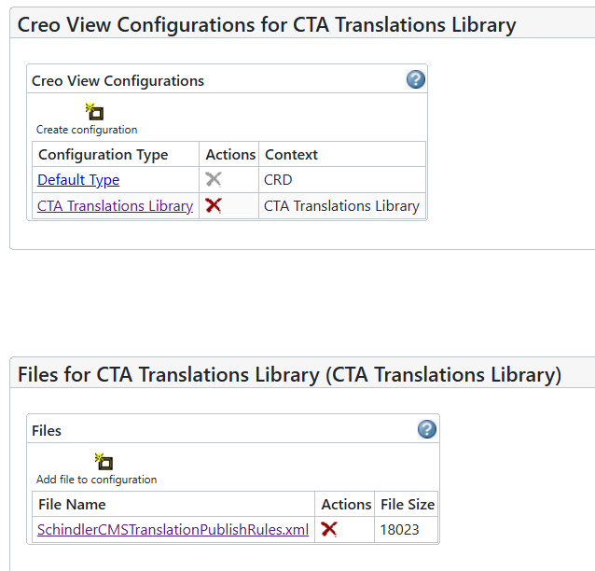

## Create AdHocAccessReport Task delegate

* Navigate to site > Utilities > Info Engine Administration

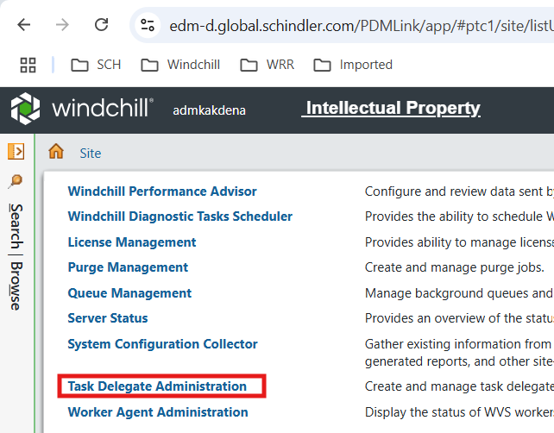

* Open Task Delegate Administration

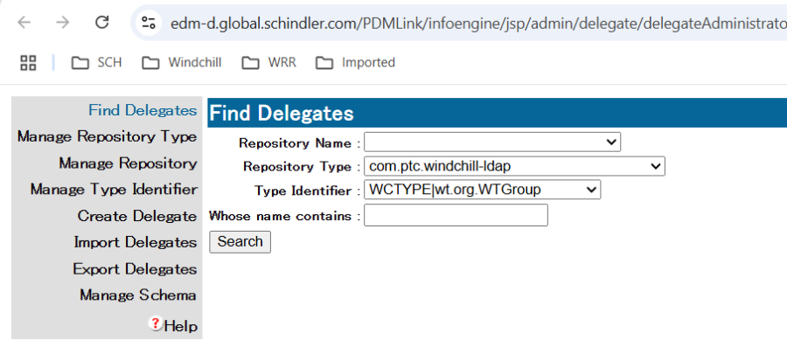

* Create AdHocAccessReport delegate with below details.
* Create AdHocAccessReport Task delegate

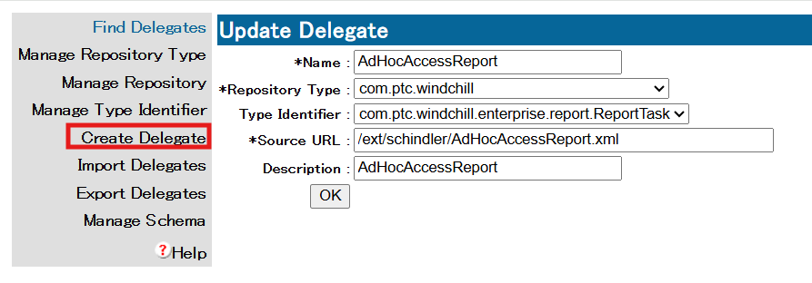

## Update Sync on CA Complete robot to use Object Event

* Edit Schindler Change Notice Workflow from Site > Utilities > Workflow Template Administration

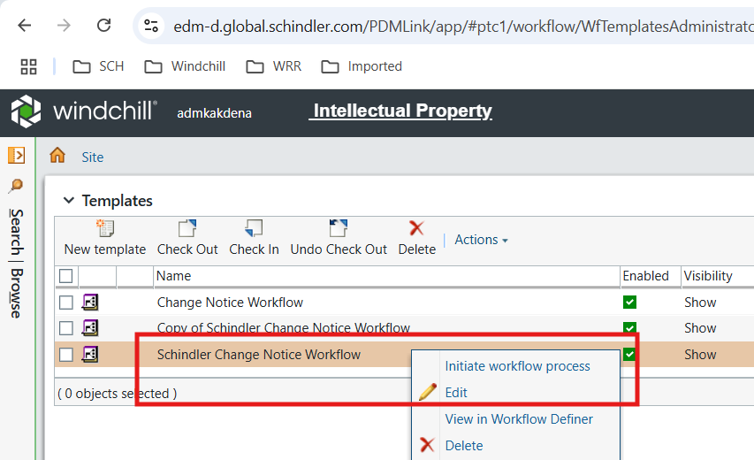

* Select Object Event in Sync on CA Complete

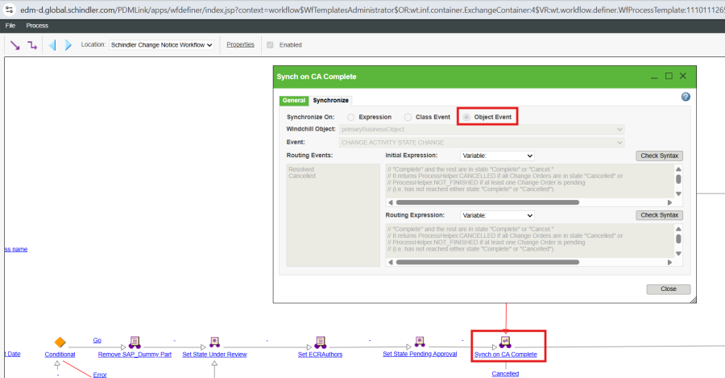

* Click on Check Syntax for initial Expression and Routing Expression.

